LDCS 11000/2022
[2026] HKLdT 19

IN THE LANDS TRIBUNAL OF THE

HONG KONG SPECIAL ADMINISTRATIVE REGION

LAND COMPULSORY SALE MAIN APPLICATION NO 11000 OF 2022
__________________________

BETWEEN

MODEST INTERNATIONAL LIMITED | Applicant
and

CROWN LANE INVESTMENT LIMITED  (光隆投資有限公司) | 1st Respondent
MA WAI YU (馬惠如), THE ADMINISTRATRIX OF THE ESTATE OF CHAN YIN YAU (deceased) | 2nd Respondent
CHAN KAM HAR (陳金霞) | 3rd Respondent
CHAN SHEK KUEN (陳石娟) | 4th Respondent
CHAN LEUNG YIM (陳良艷) | 5th Respondent
WU CHUN CHEUNG (胡鎮章) | 6th Respondent  (Discontinued)
THE PERSONAL REPRESENTATIVES OF KWAN CHI KAM (關次金) (DECEASED) | 7th Respondent
KWONG CHOR LEUNG ERIC (鄺佐良) | 8th Respondent
WEN XIAOYUN VIVIAN (温小云) | 9th Respondent
KWOK MONA (郭濛娜) | 10th Respondent
THE PERSONAL REPRESENTATIVES OF YU MAY-WAH (余美華) (DECEASED) | 11th Respondent
MA CHI CHUN THOMAS (馬似駿) | 12th Respondent
THE PERSONAL REPRESENTATIVES OF WAT MING KWONG (屈明光) (DECEASED) | 13th Respondent
KENG MING TAT (康明達) | 14th Respondent  (Discontinued)
FEDERAL HONG KONG LIMITED  (飛達香港有限公司) | 15th Respondent  (Discontinued)
WONG HO NUI (黃河女) | 16th Respondent  (Discontinued)
WELLINK (HONG KONG) LIMITED  (偉聯(香港)有限公司) | 17th Respondent  (Discontinued)
MARU LIMITED | 18th Respondent  (Discontinued)
CHUN MAN LING (秦敏玲) | 19th Respondent
CHUN WAI HO (秦緯豪) | 20th Respondent
JOEWAY LIMITED (仲通有限公司) | 21st Respondent  (Discontinued)
LEE MAN HUA (李敏華) | 22nd Respondent
ZHUANG LIYUAN (庄丽圓) | 23rd Respondent
LO CHONG SIM (羅仲嬋) | 24th Respondent  (Discontinued)
LAW KAM WOON (羅錦垣) | 25th Respondent  (Discontinued)
ASHBURTON INTERNATIONAL GROUP LTD. | 26th Respondent
MAI LAI HING (馬麗 ) | 27th Respondent
MA KING MAN (馬景文) | 28th Respondent
WAT SAU FONG | 29th Respondent

__________________________

Before: | Her Honour Judge LJ Cruden, Presiding Officer of the Lands Tribunal, and  Mr Tang Ping Kwong, Temporary Member of the Lands Tribunal
Dates of Hearing:  Date of Joint Site Inspection:  Date of Closing Submission: | 11-14 & 17-19 March 2025  12 March 2025  9 October 2025
Date of Handing Down of Judgment: |  | 31 March 2026

________________

J U D G M E N T
________________

APPLICATION

- This is the applicant’s application for a compulsory sale order dated 23 June 2022 (“the Application”) under section 3 of the Land (Compulsory Sale for Redevelopment) Ordinance, Cap 545 (“the Ordinance”). The applicant seeks to sell all the undivided shares of the following lots:
- The Remaining Portion of Section C of Marine Lot No. 703 and Sub-section 1 of Section D of ML 703 (collectively “1st Lot”) (Nos.9,11,13,15,17,19,21,23,25,27 and 29 Hoi Wan Street(“HWS”)), Hong Kong (“1st Building”);
- Sub-section 1 of Section C of ML 703 (“2nd Lot”) (Nos. 39 and 41 Tong Chong Street (“TCS”) and Nos.31 and 33 HWS (collectively “2nd Building”));
- Sub-section 2 of Section C of ML 703 (“3rd Lot”) (No. 35 HWS (“3rd Building”));
- Sub-section 3 of Section C of ML 703 (“4th Lot”) (No. 37 TCS (“4th Building”));
- Sub-section 4 of Section C of ML 703 and Sub-section 4 of Section D of ML 703 (collectively “5th Lot”) (No. 37 HWS (“5th Building”));
- Sub-section 8 of Section D of ML 703 (“6th Lot”) (No. 39 HWS (“6th Building”));
- Sub-section 5 of Section D of ML 703 (“7th Lot”) (No. 33 TCS (“7th Building”)); and
- Sub-section 5 of Section C of ML 703 and Sub-section 9 of Section D of ML 703 (collectively “8th Lot”) (No. 35 TCS (“8th Building”)).
- The 1st Building is known as Hoi Wan Building (“HWB”). The 2nd to 8th Buildings are portions of Sea View Building (“SVB”). The 1st to 8th Lots (collectively “Lots”) and the 1st to 8th Buildings (collectively “Buildings”) are referred as follows.
BACKGROUND
- HWB is a 9-storey residential/commercial building with shops on G/F served by 6 common staircases:-
- According to building plans approved in 1960-1961, seven non-domestics units were planned on G/F and eleven domestic units were planned on 1-8/F. The occupation permit (“OP”) dated 9 April 1962 grants permission for non-domestic use on G/F and 8 tenements and 3 European style flats for domestic use on each of 1-8/F.
- There are a total of 110 undivided shares and their distribution with the attached units in HWB is listed below:

Floor | Undivided Shares
Floor | Hoi Wan Street
Floor | No. 9 | No.11 | No. 13 | No. 15 | No. 17 | No. 19
G/F | 1/110 | 1/110 | 1/110 | 1/110 | 1/110 | 1/110
1/F | 1/110 | 1/110 | 1/110 | 1/110 | 1/110 | 1/110
2/F | 1/110 | 1/110 | 1/110 | 1/110 | 1/110 | 1/110
3/F | 1/110 | 1/110 | 1/110 | 1/110 | 1/110 | 1/110
4/F | 1/110 | 1/110 | 1/110 | 1/110 | 1/110 | 1/110
5/F | 1/110 | 1/110 | 1/110 | 1/110 | 1/110 | 1/110
6/F | 1/110 | 1/110 | 1/110 | 1/110 | 1/110 | 1/110
7/F | 1/110 | 1/110 | 1/110 | 1/110 | 1/110 | 1/110
8/F | 1/110 | 1/110 | 1/110 | 1/110 | 1/110 | 1/110
Roof | 1/110 | 1/110 | 1/110 | 1/110 | 1/110 | 1/110
Floor | Undivided Shares
Floor | Hoi Wan Street
Floor | No. 21 | No.23 | No. 25 | No. 27 | No. 29
G/F | 1/110 | 1/110 | 1/110 | 1/110 | 1/110
1/F | 1/110 | 1/110 | 1/110 | 1/110 | 1/110
2/F | 1/110 | 1/110 | 1/110 | 1/110 | 1/110
3/F | 1/110 | 1/110 | 1/110 | 1/110 | 1/110
4/F | 1/110 | 1/110 | 1/110 | 1/110 | 1/110
5/F | 1/110 | 1/110 | 1/110 | 1/110 | 1/110
6/F | 1/110 | 1/110 | 1/110 | 1/110 | 1/110
7/F | 1/110 | 1/110 | 1/110 | 1/110 | 1/110
8/F | 1/110 | 1/110 | 1/110 | Flat A-3(1) | 1/110
 |  |  |  | 1/2 of 1/110 | 1/110
 |  |  |  | Flat A-3(2) | 1/110
 |  |  |  | 1/2 of 1/110 | 1/110
Roof | 1/110 | 1/110 | 1/110 | 1/110 | 1/110

- In gist, 1/110 undivided share has attached and/or is allocated to each unit on G-8/F and Roof at each street number of Nos. 9,11,13,15,17,19,21,23,25,27 and 29 Hoi Wan Street, except for Flat A-3(1) and Flat A-3(2) at 8/F, No. 27 Hoi Wan Street which are each attached to or allocated ½ of 1/110 undivided shares under the Sub-Deed of Mutual Covenant dated 5 August 1980.
- HWB is governed by the Deed of Mutual Covenant (DMC) dated 3 July 1962.
- SVB is a 9-storey residential/commercial building with shops on G/F served by 7 common staircases, 5 of which serve the portions of SVB under the present application.
- According to building plans approved in 1960-61, 7 non-domestic units were planned on G/F and 14 domestic units are planned for each floor of 1-8/F. The OP dated 14 March 1961 grants permission for such uses.
- In relation to the portions of SVB under the present application:
- For the 2nd Building: 1/40 undivided share has attached and/or is allotted to each unit on G-8/F and ‘Roof and The External Wall’; and
- For each of the 3rd to 8th Buildings: 1/10 undivided share has attached and/or is allotted to each unit on G-8/F and ‘Roof and The External Wall’.

Floor | Undivided Shares
Floor | 2nd Building
Floor | Hoi Wan Street |  | Tong Chong Street
Floor | No. 31 | No. 33 | No. 39 | No. 41
G/F | 1/40 | 1/40 | 1/40 | 1/40
1/F | 1/40 | 1/40 | 1/40 | 1/40
2/F | 1/40 | 1/40 | 1/40 | 1/40
3/F | 1/40 | 1/40 | 1/40 | 1/40
4/F | 1/40 | 1/40 | 1/40 | 1/40
5/F | 1/40 | 1/40 | 1/40 | 1/40
6/F | 1/40 | 1/40 | 1/40 | 1/40
7/F | 1/40 | 1/40 | 1/40 | 1/40
8/F | 1/40 | 1/40 | 1/40 | 1/40
Roof and the External Wall | 1/40 | 1/40 | 1/40 | 1/40
 | Undivided Shares
Floor | 3rd Bldg | 4th Bldg | 5th Bldg | 6th Bldg | 7th Bldg | 8th Bldg
Floor | No. 35 Hoi Wan Street | No. 37 Hoi Wan Street | No. 39 Hoi Wan Street | No. 33 Tong Chong Street | No. 35 Tong Chong Street | No. 37 Tong Chong Street
G/F | 1/10 | 1/10 | 1/10 | 1/10 | 1/10 | 1/10
1/F | 1/10 | 1/10 | 1/10 | 1/10 | 1/10 | 1/10
2/F | 1/10 | 1/10 | 1/10 | 1/10 | 1/10 | 1/10
3/F | 1/10 | 1/10 | 1/10 | 1/10 | 1/10 | 1/10
4/F | 1/10 | 1/10 | 1/10 | 1/10 | 1/10 | 1/10
5/F | 1/10 | 1/10 | 1/10 | 1/10 | 1/10 | 1/10
6/F | 1/10 | 1/10 | 1/10 | 1/10 | 1/10 | 1/10
7/F | 1/10 | 1/10 | 1/10 | 1/10 | 1/10 | 1/10
8/F | 1/10 | 1/10 | 1/10 | 1/10 | 1/10 | 1/10
Roof and the External Wall | 1/10 | 1/10 | 1/10 | 1/10 | 1/10 | 1/10

- Each of the 2nd to 8th Building is governed by a separate DMC:
        - 2nd Building: DMC dated 14.12.1961;
        - 3rd Building: DMC dated 3.11.1961;
        - 4th Building: DMC dated 3.11.1961;
        - 5th Building: DMC dated 3.11.1961;
        - 6th Building: DMC dated 14.12.1961;
        - 7th Building: DMC dated 14.11.1961; and
        - 8th Building: DMC dated 3.11.1961.
THE PARTIES
- At the time of filing the Application on 23.6.2022, the applicant owned the following undivided shares:
- 93.64% in the 1st Lot;
- 87.5% in the 2nd Lot;
- 90% in the 3rd lot;
- 90% in the 4th Lot;
- 100% in the 5th Lot;
- 90% in the 6th Lot;
- 90% in the 7th Lot; and
- 80% in the 8th Lot.
- At the time of the Application, the applicant owned not less than 80% undivided shares of the Lots (which is not disputed). The applicant is entitled to make the present application as the above percentages satisfy s.3(2) of Cap 545 and s.4(1)(b) of Cap 545A and the relevant OPs were issued in 1961-1962, i.e. more than 50 years before the Application of 2022.
- The outstanding respondents and their properties are:
- The 1st respondent (“R1”) is the registered owner of Ground Floor, No. 11 of Hoi Wan Street (Hoi Wan Building) (Shop 11). Upon agreement between R1 and the then owner of Ground Floor, No. 9 of Hoi Wan Street (i.e. its adjacent shop), Shop 11 became merged with Shop 9 to form a merged shop since about 2005 by partially knocking down the division wall between them. The combined shop is currently known as “Merged Shop E”. It was jointly let as a single unit by R1 and the then registered owner of Shop 9 to a tenant to operate an eatery. Notwithstanding Shop 9 was acquired by the applicant since about 2017, the co-letting arrangement of Shop E subsists.
- The 2nd to 5th respondents (“R2-R5”) are the registered owners holding as tenants in common with ¼ share each of Ground Floor, No. 27 Hoi Wan Street (Hoi Wan Building).
- The 8th and 9th respondents are the registered owners holding as joint tenants of 4th Floor, No. 19 Hoi Wan Street (Hoi Wan Building).
- The 10th respondent is the registered owner of 8/F, No. 11 Hoi Wan Street (Hoi Wan Building).
- The 12th respondent is the registered owner of 3/F, No. 33 Hoi Wan Street (Sea View Building).
- The 19th and 20th respondents are the registered owners holding as tenants in common with ½ share each of 4/F, 39 Hoi Wan Street (Sea View Building).
- The 22nd and 23rd respondents are the registered owners holding as joint tenants of 4/F, No.35 Tong Chong Street (Sea View Building).
- Further, there are the following outstanding respondents in relation to various adjudicated and pending adverse possession claims:
- The 7th respondent (“R7”) is the personal representative of the late Kwan Chi Kam – the registered owner of 4/F, No. 9 Hoi Wan Street (Hoi Wan Building). The 26th respondent (“R26”) (the applicant’s associated company) obtained an order that R7’s title to the said property has been extinguished and R26 acquired a possessory title to it by way of adverse possession. In the present application, service on R7 and R26 has been dispensed with.
- The 11th respondent (“R11”) is the personal representative of the late Yu May Wah (“Yu”) – the registered owner of 8/F, No. 25 Hoi Wan Street (Hoi Wan Building). By a Declaration of Trust dated 16.12.1969, Yu declared that she held the said property upon trust for the 27th respondent (“R27”). In DCCJ 1112/2022, the 28th respondent (“R28”) claimed adverse possession against Yu and R27 but that action has been discontinued. In DCCJ 2419/2022 and DCMP 4326/2023, R28 claims adverse possession against R27 and R11/27 respectively. In the present Application, R28 acts in person and service on R11/R27 has been dispensed with.
- The 13th respondent (“R13”) is the personal representative of the late Wat Ming Kwong – registered owner of 6/F, No. 39 Tong Chong Street (Sea View Building). The 29th respondent (“R29”) claims adverse possession against R13 in relation to the said property under DCCJ 3983/2022. In the present Application, R29 is represented by Messrs JCC Cheung & Co and service on R13 has been dispensed with.
- R1, R2-R5, R10 and R12 filed Notices of Opposition disputing valuation and whether reasonable offers were made only. R19/20 dispute valuation only and not age or state of repair. R29’s solicitor gave notice that R29 shall not make any legal submissions in opposition to the application for order for compulsory sale.
THE EVIDENCE
- For the purpose of the present proceedings, the applicant and the respondents have filed the following witness statements:
Applicant –
- Ms Man Kwai Fong dated 28.2.2023. Ms Man has been involved in the acquisition by the applicant of the units in the Buildings and Lots;
- Mr Charles C K Chan (“Mr Chan”), a Fellow of the Hong Kong Institute of Surveyors (“HKIS”) (General Practice Division) dated 24.2.2023;
- Mr Dennis W C Wong (“Mr Dennis Wong”), a Fellow of the HKIS (Building Surveying Division) and also a Registered Structural Engineer dated 28.2.2023; and
- Mr Wong Chi Ming (Mr C M Wong), a Registered Structural Engineer dated 27.2.2023.
Respondents –
- R1 (Knight Ng May Lynette) dated 30.8.2023;
- R2 (Ma Wai Yu) dated 28.8.2023;
- R3 (Chan Kam Ha) dated 29.8.2023;
- R4 (Chan Shek Kuen) dated 27.8.2023;
- R5 (Chan Leung Yim) dated 29.8.2023;
- R10 (Kwok Mona) dated 31.8.2023;
- R12 (Ma Chi Chun Thomas) dated 31.8.2023; and
- R29 (Wat Sau Fong) dated 26.6.2023.
- Moreover, the applicant and the respondents have produced the following expert reports:
Condition Survey
Mr Dennis Wong, on behalf of the applicant, filed a Condition Survey Report dated 28.2.2023.
Structural Assessment
Mr C M Wong, on behalf of the applicant, filed a Structural Assessment Report dated 27.2.2023.
Valuation
- Mr Chan, on behalf of the applicant, filed the following reports:
- Valuation Report dated 30.3.2022 on the existing market value (“EUV”) of the Buildings;
- Supplemental Report dated 24.2.2023 on the EUV of the Buildings as at 30.3.2022 and the Redevelopment Value (“RDV”) of the Lots as at 9.2.2023;
- Rebuttal Report dated 29.12.2023 on the EUV of the Buildings and RDV of the Lots;
- Valuation Report dated 3.2.2025 on the updated RDV.
- Mr Patrick W C Lai (“Mr Lai”), also a member of the HKIS (General Practice Division), on behalf of the 1st Respondent, filed the following reports :
- EUV Report dated 30.3.2022 and RDV Report dated 1.8.2023; and
- Updated RDV Report dated 27.1.2025.
- Mr Chan and Mr Lai jointly filed the following:
- 1st Joint Statement dated 28.2.2024;
- 2nd Joint Statement dated 26.2.2025;
- Consolidated tables filed on 27.2.2025 for EUV and RDV;
- Inspection bundle filed on 27.2.2025; and
- Exhibits and final consolidated tables filed on 22.4.2025 for EUV and RDV.
- None of the respondents filed any expert evidence on building condition or structural assessment.
- The issues to be determined in this case are as follows:-
- Whether the applicant has satisfied the prerequisites as set out in section 3(1) of the Ordinance and is entitled to make the present application? (“Issue 1”)
- What was the market value of each property on the Lots as at 30 March 2022 as assessed in accordance with sections 3(1)(a), section 4(1)(a)(i) and Part 1 of Schedule 1 of the Ordinance? (“Issue 2”)
- Whether the redevelopment of the Lots is justified due to the age or state of repair of the Buildings in accordance with section 4(2)(a)(i) of the Ordinance? (“Issue 3”)
- Whether the applicant has taken reasonable steps to acquire all the undivided shares in the Lots on terms that are fair and reasonable in accordance with section 4(2)(b) of the Ordinance? (“Issue 4”)
- If an order for sale is granted, what should be the reserve price for the purpose of public auction? (“Issue 5”)
ISSUE 1: ENTITLEMENT TO MAKE APPLICATION
- Section 3(1) of the Ordinance requires an applicant to have not less than 90% of the undivided shares in a lot before he can make an application.
- Section 3(5) of the Ordinance provides that the Chief Executive in Council may, by notice in the Gazette, specify a percentage lower than the percentage mentioned in section 3(1) in respect of a lot belonging to a class of lots specified in the notice.
- The Land (Compulsory Sale for Redevelopment) (Specification of Lower Percentage) Notice (“Notice”) was gazetted on 22 January 2010 and came into operation on 1 April 2010. Section 3 of the Notice lowered the threshold for compulsory sale in respect of the classes of lots specified in the Notice from 90% to 80%. Those classes of lots include “a lot with each of the building erected on the lot issued with an occupation permit at least 50 years before the relevant date (ie the date of the application under the Ordinance)”.
- Given the OPs were issued in 1961-62, over 50 years before the date of the Application, the Notice is applicable and the threshold percentage is 80%. Accordingly, we find that the applicant, being the owner of not less than 80% of the undivided shares of the Lots upon the filing of the Application is entitled to make the Application under section 3(1) of the Ordinance.
ISSUE 2: MARKET VALUE
- There are no legal issues concerning the assessment of existing market value (EUV) of the Buildings.
EUV AS AT 30 MARCH 2022
- Mr Chan and Mr Lai outline their agreements and differences in opinion in relation to the EUV assessment in their 1st joint statement dated 28 February 2024 (“1st JES”).
GROUND FLOOR SHOPS
- Ground floor shops at the Buildings are occupied as eateries (unless vacant). On valuation approach, both Mr Chan and Mr Lai agree to take into account unauthorised building works and encroachments. They also agree that some shops are assessed as merged shops while others as separate single shops :-
  - Merged Shop A: G/F, 13-15 HWS (HWB);
  - Merged Shop B: G/F, 17-21 HWS (HWB);
  - Merged Shop C: G/F, 31-37 HWS and 35- 41 TCS(SVB);
  - Merged Shop D: G/F, 39 HWS & 33 TCS (SVB) (Agreed reference shop);
  - Merged Shop E: G/F, 9-11 HWS (HWB); and
  - 4 single shops, namely, G/F of 23, 25, 27 and 29 HWS (HWB).
- Merged Shop E is under separate ownership and the valuation surveyors agreed to apportion the assessed EUV of Shop E to G/F, 9 HWS and G/F, 11 HWS in the ratio of 54.3% and 45.7% respectively.
- The valuation surveyors also agreed that the unit rate for the reference shop (Merged Shop D) is $452,490 per sq m.
- Both valuation surveyors agree on the saleable areas, encroached areas and sitting areas for all shops, except for the sitting area of Merged Shop E. They also disagree on how to value the sitting areas for all shops.
- The dimensions for frontages, depth and headroom are agreed, except that Mr Chan and Mr Lai disagree on whether some of the frontages are blocked.
- Adjustments on frontage and return frontage, layout and headroom are agreed. Yet they disagree on adjustments for location, size and building age. The various adjustments applied by Mr Chan are shown in the table at Appendix 1, whereas those adjustments made by Mr Lai, if different, are shown in italics.
Sitting Area – Valuation Approach
- It is not disputed that there are sitting areas in front of Shops 23, 25, 27 and 29 Hoi Wan Street, Merged Shop A and Merged Shop E, and there are no sitting area in front of Merged Shop B, Merged Shop C and Merged Shop D.
- The sitting areas are subject to a revocable licence granted by the Incorporated Owners (IO) to the licensee (the shop operator) which allows the licensee the non-exclusive use of the common parts upon payment of licence fee ($3,000 per month) and drainage clearance fund ($500 per month). According to the licence agreement, the licence shall be personal to the licensee. The IO and the licensee can terminate the licence upon 5 business days written notice to the other parties. The depth of the sitting areas is 3 metres from the shop front, while the width varies according to the width of the shops. Despite the difference in size of the sitting areas, the licensees pay the same amount of licence fee and drainage clearance fund.
- The IO did not grant a licence of sitting areas to all shop operators – the application for a licence of sitting areas by tenant of Merged Shop B (17, 19 and 21 Hoi Wan Street) was refused and therefore Merged Shop B has no sitting areas.
- Mr Mok submits that, as a matter of principle, the benefit of using the sitting areas should only be regarded as part of the value of the licence agreement - which benefit is not available to anyone but for that specific shop operator. The benefit should not be regarded as part of the value of the tenancy agreement (or that of the shop). For present purposes we do not differentiate on that basis, when the issue is one of valuation. Instead, the Tribunal considers the focus should be on what extra sum (if any) would a hypothetical buyer be willing to pay for such benefit, namely use of the sitting area on a non-exclusive basis, under the principle of market reality. This is a matter of valuation.
- It is not disputed that both valuation surveyors attach value to the non-exclusive use of the sitting areas. The only dispute is the valuation approach – Mr Chan ‘embeds’ the adjustment into the location adjustments, whereas Mr Lai applies a conversion factor of ¼, which is the same factor as adopted by both parties in valuing the unauthorised covered area. Mr Chan explained that his adjustment reflects the “opportunity” to use the sitting areas via licence.
- Mr Adrian But (Mr But), counsel for R1, submits that “conceptually, location adjustment only relates to its physical whereabouts (i.e. visibility, ease of access, exposure) that affects the value and commercial potential of a shop for the purpose of assessing the adjusted unit rate of the ‘saleable areas’ of the shop proper…” and Mr Chan’s “blending” approach is wrong. Mr But adds that sitting areas form part and parcel of an ancillary area of the Shop and must be given separate treatment by way of conversion factor – which is the longstanding approach as adopted by the Tribunal in previous cases.
- We agree with Mr Mok’s submission that the label is not important. As long as the benefit is reflected in EUV assessment, it matters not whether the benefit of sitting areas is included in location adjustment or labeled as a standalone adjustment. That said, we prefer Mr Lai’s conventional approach in this instance as it is easier to understand and it quantifies the size of the sitting areas. Because of difference in shop frontages, the size of the sitting areas varies from 27.3 sq m to 44.3 sq m. The “additional” location factor of 5% adopted by Mr Chan in reflecting the benefit of sitting area seems to focus on the saleable areas of the shop proper only, but ignores the size of the sitting areas. Using Mr Chan’s approach, two shops having the same saleable area and opposite to each other, will attract the same additional value despite the difference in sitting areas. This is not logical.
- We are of the view that the enforcement risk of the sitting areas or the termination of the licence by the IO is low. R1 stated in her witness statement that the use of the sitting areas of Merged Shop E (9 & 11 Hoi Wan Street) had started back in about 2005 and had never been objected to by the IO. The applicant did not challenge this statement.
- Similarly we consider the enforcement risk of removing the encroachment at Shop B is low. We note that the valuation experts agree to adopt a conversion factor of 1/9 to ‘encroached open area’ at Shop B as ancillary area. Shop B tenant has exclusive use of the encroached area 24 hours a day. By contrast, the licensee of the sitting areas only has an non-exclusive use of the area. We consider that a conversion factor of 1/10 is appropriate in this instance. Mr Lai admitted during cross-examination that after seeing the licence agreements, his conversion factor may be 1/5, 1/10 or even 1/20.
Sitting Areas - Size
- The size of sitting areas for all relevant shops has been agreed except that of Merged Shop E (9 & 11 Hoi Wan Street). The difference is shown on IB/6: Mr Chan adopts area (b) and Mr Lai adopts area (a) + area (b). This dispute is relevant to Mr Lai’s valuation approach on applying a conversion factor based on the size of the sitting areas.
- We agree with Mr Chan that area (a) should not be included as sitting areas. Photographs presented to the Tribunal show that tables and chairs are only placed within area (b) (not beyond the drains on the ground). During cross-examination, Mr Lai accepted that only area (b) was obtained by way of licence. While Mr But and Ms Emily Ting (counsel for R2-5) submit that area (a) should be included as part of the sitting areas because it is the waiting or circulation area for Merged Shop E, we do not agree. In contrast, we agree with the view of Mr Chan that such area should not be given value. During cross-examination, Mr Chan drew an analogy to the situation where the public pavement outside restaurants is not given value even when their patrons wait there before getting in. Moreover, we are of the view that the IO, who wishes to have a free passage to Lincoln House, will take enforcement action if the licensee occupies area (a). Area (a) should be excluded from sitting areas for Merged Shop E.
Location
- For ease of reference, both valuation experts agree to classify the shops into 4 groups. The agreed reference shop is Merged Shop D which is in group 1 and is facing Tong Chong Street. The location adjustments by both experts are explained in D4/920-921, as supplemented by Mr Mok and Mr But in their closing submissions. Mr Chan embeds the benefit of sitting areas into his location adjustments, whereas Mr Lai, using the conventional approach, treats the sitting areas as ancillary area of the shop and his location adjustments only reflect the degree of pedestrian flow and street exposure that may affect the business potential of shops by their geographical position. The Tribunal’s following determinations on the quantum of adjustment reflect Mr Lai’s approach.
Group 2 shops – facing Hoi Wan Street
17, 19 & 21 Hoi Wan Street – Mr Chan suggests -5%, whereas Mr Lai adopts 0%. We consider -5% is appropriate.
23 Hoi Wan Street – in §2 of EB/3 and at trial, Mr Chan clarified that the location adjustment should be 0% instead of -5% after taking into account the benefit of sitting areas (at +5%). In essence, his location adjustment (excluding the sitting area location adjustment) is -5% as compared with Mr Lai’s 0%. We prefer Mr Lai’s 0%.
Group 3 shops – facing HWB-SVB lane
25, 27, 29 Hoi Wan Street – Mr Chan’s adjustment is -10% (excluding sitting area location adjustment), whereas Mr Lai adopts -5%. The Tribunal considers -10% is more appropriate in this instance.
Group 4 shops – facing HWB-Chinachem lane
Merged Shops A and E are under this group. Mr Chan suggests -30% (includes +5% location adjustment for sitting areas), whereas Mr Lai proposes -15%. Mr But’s closing submission for R1 suggests a new location adjustment of -5% (as opposed to -15% proposed by his own expert Mr Lai), citing that their customer flow is comparable to 27 and 29 Hoi Wan Street (where Mr Lai takes -5% for location adjustment). The new location adjustment was not put to Mr Chan, who was deprived of an opportunity to comment. We agree with Mr Mok’s submission that Shops 27/29 cannot be compared with Merged Shops A & E as the lane fronting the former group is double the width of the latter and thus their location traits are also different. That said, we consider a location adjustment of -20% would be sufficient to reflect the difference in trading potential between Merged Shop A & E and the reference shop.
Size
- Mr Chan proposes a non-linear progressive size adjustment at 1% per 10 sq m difference (size less than 100 sq m) and 1% per 15 sq m difference (size 100 sq m or above), reporting that units with large areas are less sensitive to size and the difference will become less significant if the size is large. Mr Lai proposes a linear adjustment of 1% per 10 sq m difference. We agree with Mr Chan.
Building Age
- Mr Chan proposes 1% per 5 years difference, reporting that the same 1% per 5 years difference was also accepted by the Lands Tribunal in the judgment of LDCS 28000/2020 (at §53) that “ it has been trite that the value of a G/F shop is not sensitive to its age. Age allowance is however required to reflect the state of the building fabric and building services.” Mr Lai proposes 1% per 3 years difference. We adopt Mr Chan’s 1% per 5 years in this instance. That said, we wish to point out that whilst Mr Chan proposed 1% per 5 years in the cited case where he acted as the applicant’s valuation expert, the Tribunal eventually determined an adjustment of 1% per 10 years difference as suggested by the respondent’s expert witness.
- In view of the above observations, our determination of various adjustments (in bold) as well as the market value of each shop is shown in Appendix 2. The EUV of the retail portion is assessed at $403,830,000.
Upper Floor Domestic
- The valuation surveyors agree on all valuation parameters and adjustments. The only dispute is on noise. Mr Chan makes no adjustment, while Mr Lai adopts -2% for all units on 1/F and 2/F.
- In Peace Ever Ltd v Au Kai, LDCS 28000/2018 (unreported, dated 1 August 2023), the Tribunal disagreed with Mr Lai (who represented the respondent in that case) that residential units on low floors would be affected by noise nuisance to a relatively greater extent. Based on scientific research, residents of upper floor units do not necessarily suffer less noise because they hear noise emitted from a larger area, ie more sources of noise from the moving traffic, whereas residents on lower floors hear noises mainly in close proximity. The Tribunal appreciates that Mr But argues for noise adjustment due to the mechanical noises generated from air-conditioners on the wall near 1/F and 2/F and also that 1/F and 2/F units are more prone to noise disturbances caused by customers of ground floor eateries.
- At the joint site visit on 12 March 2025, 1/F and 4/F of 25 Hoi Wan Street were inspected. Upon opening the windows, we do not accept that there is notable nuisance that warrant adjustment on noise. Accordingly, we accept Mr Chan’s valuation on the domestic units which are now set out at Appendix 3. The total market value for the upper floor domestic units is $731,660,000.
- According to our assessment, the EUV of the Buildings as at 30 March 2022, is as follows –
 | EUV
G/F Retail | $403,830,000
Upper Floor Domestic | $731,660,000
Total | $1,135,490,000

Conclusion of EUV as at 30 March 2022
- From the above, it is our view that the total EUV for the Buildings is $1,135,490,000. The corresponding EUV and proportionate share of the sale proceeds of respondents pursuant to Part 3 of Schedule 1 to the Ordinance are as follows:
 | Unit | EUV | Pro Rata Share of Sales Proceeds
R1 | 11 Hoi Wan Street, G/F | $17,644,770 | 1.5539%
R2-5 | 27 Hoi Wan Street, G/F | $21,230,000 | 1.8697%
R7 | 9 Hoi Wan Street, 4/F | $4,340,000 | 0.3822%
R8, R9 | 19 Hoi Wan Street, 4/F | $3,960,000 | 0.3487%
R10 | 11 Hoi Wan Street, 8/F | $3,500,000 | 0.3082%
R11 | 25 Hoi Wan Street, 8/F | $4,360,000 | 0.3840%
R12 | 33 Hoi Wan Street, 3/F | $3,550,000 | 0.3126%
R13 | 39 Tong Chong Street, 6/F | $3,800,000 | 0.3347%
R19, R20 | 39 Hoi Wan Street, 4/F | $4,100,000 | 0.3611%
R22, R23 | 35 Tong Chong Street, 4/F | $4,830,000 | 0.4254%

ISSUE 3: AGE OR STATE OF REPAIR
Law on whether redevelopment of the Lot is justified
- Section 4(2) of the Ordinance provides that the Tribunal shall not make an order for sale unless it is satisfied that the "age or state of repair" of the Building is justified and that the applicant has taken "reasonable steps" to acquire all the undivided shares of the Lot.
Section 4(2)(a)(i) – whether the redevelopment is justified due to the age or state of repair of the existing development on the lot
- The applicant adduced witness statements and expert reports of Mr Dennis Wong and Mr C M Wong. Mr Dennis Wong, both a building surveyor and a structural engineer, filed a Condition Survey Report dated 28.2.2023. Mr C M Wong, a structural engineer, filed a Structural Assessment Report dated 27.2.2023.
- None of the respondents filed any expert evidence on building condition or structural assessment. Mr Dennis Wong and Mr C M Wong gave evidence but were not cross-examined by the respondents.
- Having considered the report and evidence of Mr Dennis Wong, we accept his expert opinion. The Buildings, being erected more than 60 years ago, are in a poor state of repair rendering them below tenantable standard and falling short on many basic requirements expected in modern buildings. The costs of repair to bring the Buildings to a tenantable standard is disproportionate to the costs for reconstructing a new similar building (at around 35%). Even after the essential repairs, the Buildings will each remain an old building with their design and construction obsolete and below current standards and market expectations.
- Mr C M Wong stated in his Structural Assessment Report that the structural elements of the Buildings are in poor condition with problems from the cracks/spalling from visual inspection and corrosion/carbonation of steel reinforcement bars from test results. We also accept his expert opinion.
- By reason of matters set out above, we are satisfied that the redevelopment of the Lots is justified due to the age or state of repair of the Buildings in accordance with section 4(2)(a)(i) of the Ordinance,
ISSUE 4: REASONABLE STEPS TO ACQUIRE
Section 4(2)(b) – Whether applicant has taken reasonable steps
- The applicant is under an obligation to take reasonable steps to negotiate on terms that are fair and reasonable for the purchase of the interest of the respondents under section 4(2)(b) of the Ordinance.
- It is not disputed that the applicant has made the following offers to the respondents directly or through their solicitors to acquire the units or interests:-
 | 1st round offers (made between 4/2022-2/2023) | 2nd round offers made on 28 February 2025
R1 | $40,200,000 | $22,350,000
R2-5 | $59,700,000 | $30,370,000
R7/26 | $10,700,000 | $6,470,000
R8, R9 | $9,400,000 | $5,900,000
R10 | $8,100,000 | $5,210,000
R11/27/28 | $10,700,000 | $6,500,000
R12 | $8,200,000 | $5,290,000
R13/29 | $9,100,000 | $5,660,000
R19, R20 | $9,500,000 | $6,110,000
R22, R23 | $10,900,000 | $7,200,000

- None of the above offers was accepted by the respective respondents. Mediations between the parties with a view to arrive at settlement also failed.

- The Court of Final Appeal in Capital Well Ltd v Bond Star Development Ltd [2005] 4 HKLRD 363 §33 emphasises that:
“In making that assessment (whether an offer is reasonable) the Tribunal is not conducting a valuation exercise. It does not need to adjudicate upon any disputes about the correct valuation principles to be applied. It does not itself arrive at any conclusion as to what figure represents the correct valuation. It merely needs to be satisfied that, on the evidence available, the offer falls within the range of what may broadly be regarded as fair and reasonable compensation for the interest in question.”
- The Court of Final Appeal stated further at §36 that:
“ … What the Tribunal must do is to consider whether, in the circumstances of each case, the offer falls within a band of what represents a fair and reasonable assessment of the value of the minority owner’s interest reflecting a proportionate share of the redevelopment value of the whole site…”
- With these principles in mind, we are satisfied that the applicant has fulfilled such requirement for those offers were well-supported by detailed analysis of an experienced valuation expert. The first round of offers made on 7 April 2022 were all supported by the letters of advice of Savills. The second round of offers were made with reference to Mr Chan’s revised and updated valuation in the First Valuation Joint Statement dated 28 February 2024 and the Second Valuation Joint Statement dated 26 February 2025.
- In the second round of offers, the assessment basis and calculation of the offer prices were set out therein, with the relevant expert reports specifically referred to. The offer prices were clearly based on Mr Chan’s assessments by applying his assessed pro-rate share of sales proceeds of the respondents’ units to his assessed market value of the Lots on redevelopment basis.

- In Intelligent House Ltd v Chan Tung Shing & Others [2008] 4 HKC 421 where the majority owner relied on its valuation expert to formulate some of the offers, the Tribunal ruled at § 334 that:
“(3) …it is not disputed that Savills is a reputable firm of valuers. In our view, it is also reasonable for Intelligent House to rely on Savills’ expert opinion to formulate the purchase prices offered to the minority owners. There is also no reason for us to believe, nor is there such evidence to suggest, that the advices from Savills were not properly made based on professional valuation of the EUV and RDV of the minority owners’ units.
(4) In the circumstances, we are satisfied that the offers made by Intelligent House to the minority owners to purchase their units offer fall within the range of what may broadly be regarded as fair and reasonable compensation for the interest in question.”
- Given the offers here were supported by detailed analysis of an experienced valuation surveyor as elaborated in his expert reports, we are of the view that the requirement under section 4(2)(b) of the Ordinance has been satisfied.
- The respondents raise no argument on whether reasonable steps have been taken. Applying the aforesaid guiding principle to the present facts, it is clear to us that the applicant’s offers plainly fall within the range of what may broadly be regarded as fair and reasonable compensation for the interest of the respondents. We are satisfied that on the evidence and in the circumstances of the Application, the applicant has taken reasonable steps to acquire all the undivided shares in the Lots including negotiating for the purchase of such of those shares owned by the respondents on terms that are fair and reasonable.
- Mr But invites the Tribunal to cross-check as to whether the offers made were reasonable after assessment of the EUV and the RDV. In our view that is not the proper approach and would serve no material purpose.
ISSUE 5: RESERVE PRICE
Estimation of the RDV
- Both Mr Chan and Mr Lai agree to use the residual method of valuation in determining the RDV. This involves deducting development cost (including construction cost, professional fees, finance cost) and developer’s profit from the estimated gross development value (“GDV”) of the completed optimum development.
- The two valuation experts agree that the Lots have a net site area of 1,628.8 sq m for Gross Floor Area (“GFA”) calculation and the proposed GFA is 24,432 sq m. The valuation date is 3 February 2025. At trial, it was agreed that Mr Lai’s proposed hypothetical model is to be adopted for RDV assessment. It is a 29-storey composite commercial development with shops on G-2/F and offices on 3-28/F (with 15/F as refuge floor). There are 6 shops on G/F, 4 shops on 1/F and 2 shops on 2/F. There are 3 office units per floor on the upper floors. The hypothetical model has curtain walls but there is a dispute on the treatment of the curtain wall areas of the office portion, depending on the comparables to be adopted.
- Both experts agree on all the parameters of the residual method except the interest rate and developer’s profit. The agreed parameters are as follows:
Form of the hypothetical development | B/F – Plant Room  G/F – Retail shops, office entrance hall, plant room;  1/F – Retail shops, office lift lobby, plant room;  2/F – Retail shops, plant room;  3/F-28/F (except 15/F) – Office units  15/F – Refuge floor
Saleable area of hypothetical development | G/F Retail : 880.913 m²  1/F Retail : 921.124 m² + curtain wall 27.113 m²  2/F Retail : 892.249 m² + curtain wall 24.288 m²  Upper Floor Office : 17,207.586 m² + curtain wall 610.485 m²
Marketing cost | 3.0%
Professional fees | 6.0%
Demolition cost | $19,554,920
Construction cost | $1,058,986,605
Demolition period | 9 months (0.75 year)
Construction period | 35 months(2.92 years)
Stamp duty | 4.25%
Legal cost | 0.1%

Ground Floor Retail
- Both valuation experts agree to adopt hypothetical shop no. 4 on G/F as the reference retail unit. However, they could not agree on the adjusted unit rate of the comparables. Parties differ on adjustments on location, size, age, accessibility and quality of building. Mr Chan relies on 2 comparables (D1 & D2) in the vicinity, whereas Mr Lai includes 2 more comparables (D3 & D4) in his valuation exercise. The details of adjustments for ground floor shop is at Appendix 4. Mr Chan’s fall back adjustments on D3 and D4 (if the Tribunal accepts D3 and D4 as suitable comparables) are shaded in the table.
Location
- R1 submits that D1 is “located at a slanted position which deters business potential as customers are often less likely to do shopping when walking up or down sloped terrain”. Moreover, the carpark entrance nearby also renders walking along the side of D1 to be more dangerous and less preferred than the opposite side. The pedestrian flow is not high when compared with Tong Chong Street where office workers of Taikoo Place commute daily. Mr Lai proposes a 15% adjustment. On the contrary, Mr Chan proposes 5% adjustment. The applicant submits that the slope is mild and the car park is for a residential building which does not attract high traffic volume. Mr Chan also commented in cross-examination that people going to One Island East need to go past Westlands Road (on which D1 stands) off King’s Road. Overall, we consider 10% adjustment is appropriate in this case.
- On D3, Mr Chan proposes 10%, whereas Mr Lai proposes 30%. It is not disputed that D3 is located at an inferior and less popular spot as compared with the subject being located at the Hoi Wan Street cluster. Yet D3 is close to Quarry Bay MTR Exit A. We consider 20% is sufficient.
- On D4, Mr Lai suggests making no adjustment as both D4 and the reference shop are located on Tong Chong Street within about a minute’s walk. There is little difference in terms of pedestrian flow. Mr But further submits that “ … when the retail portion of the site is to be redeveloped near the cluster of skyscrapers, the retail portion would bring about even better synergy after regeneration. Such improvement to be brought about by gentrification of Hoi Wan Building will NOT be found in D4. For such reasons, the hypothetical subject retail shop would enjoy better commercial potential than D4”. On the other hand, Mr Chan considers that D4 is more vibrant with shops for daily necessities and proposes a -10% adjustment. Mr Mok adds that “… the scale of the subject hypothetical development is relatively small when compared to the size of the existing cluster of office blocks in Taikoo Place, hence the enhancement in trading potential brought about by the subject redevelopment will be minimal. In any event, neither Mr Lai nor Mr Chan saw it fit to apply an adjustment on business improvement”. Having inspected the surrounding area and in view of the small scale of the hypothetical development, we consider a -5% adjustment is appropriate in the present case.
Size
- Mr Chan suggests 1% per 10 sq m (smaller than 100 sq m) and 1% per 15 sq m (larger than 100 sq m). R1 in closing had no strong view over the progressive quantum adjustments adopted by Mr Chan, which we accept.
Age
- Mr Chan proposes 1% per 5 years difference, whereas Mr Lai suggests 1% per 3 years difference. As determined at paragraph 40 above, we consider 1% per 5 years difference is appropriate.
Accessibility
- Mr Lai proposes a downward adjustment of 5% and 10% to comparable D1 and D2 respectively as steps at frontage of both shops pose obstruction to customers. On the other hand, having inspected the comparables, Mr Chan considers the impact to the accessibility is nominal. There are only 2 steps at the front of Shop LG3B (part of D1) and 3 steps at D2. Moreover, Shop LG3A (part of D1) can be accessed from Westland Road without any steps. We agree with Mr Chan.
Quality of Building
- Citing China Orchid, LDCS 7000/2018 §257 and Asia Rich, LDCS 15000/2019 §98 where the Tribunal adopted adjustments on quality of building to hypothetical offices, Mr But submits there is no reason why such adjustment factor should not be applied to G/F shops as their quality is also enhanced due to advancement in technologies (e.g. ventilation systems, building facade, firefighting/drainages etc.) and proposes a +10% adjustment in addition to building age. On the other hand, Mr Chan explained in D6/1367 that it is common for retailers to renovate before commencing business and the impact of building quality is insignificant in light of the trades in the vicinity which do not require state-of-the-art facilities like up-market retailers. He suggests 0% adjustment. Mr Mok submits in his closing that adjustments on Age alone are sufficient. He relies upon Peace Ever, LDCS 28000/2018 at §397 where the Tribunal also adopted only age adjustments without another adjustment on building quality for the hypothetical shop. We agree with Mr Chan and Mr Mok. It is not necessary to make any building quality adjustment to the hypothetical shop.
Common Comparable D2
- There is a dispute on floor area and headroom of D2.
Floor area
Mr Lai considers, despite that the area in the assignment plan of 1973 includes the disputed area of 11.9 sq, according to the 1972 approved building plans the disputed area of 11.9 sq m in fact belongs to a common part, namely part of the lift lobby and a 4th lift behind the position of the pipe duct. He applies a conversion factor of 1/6 to reflect the risk of enforcement by the Building Authority. Mr Mok submits that it is wrong for Mr Lai to rely on Building Authority’s approved plan to identify common area. Mr Mok submits that:
“S.2 of the Building Management Ordinance (Cap 344) defines “common parts” as “the whole of a building, except such parts as have been specified or designated in an instrument registered in the Land Registry as being for the exclusive use, occupation or enjoyment of an owner” and prevails over any term in the DMC. Such definition of “common parts” in Cap 344 applies to Cap 545 (see: Gainfield Investment Ltd v Legend Time Ltd (LDCS 16000/2014) at §§ 81-83.”
Mr Mok further submits that the assignment plan is the proper guide to identify common area and in this case such plan covers the disputed area and therefore Mr Chan’s calculation of saleable area of D2 should be adopted (i.e. main area plus disputed area without any discount by applying the conversion factor as proposed by Mr Lai).
We agree with Mr Mok. We are of the view that risk of enforcement action by the Building Authority on the disputed area is low.
Headroom
D2 is situated on a slope on King’s Road. Mr Chan opines that as the headroom of D2 varies with the changing of ground level at the relevant section of King’s Road, it is more appropriate to take the average headroom of the comparable. On the other hand, Mr Lai measures the headroom of D2 from the highest spot level of the shop. From the joint site inspection and also the photographs at Inspection Bundle pages 26-27, it is clear that a platform was constructed on and above the ground level of the slope. There is no varying headroom inside the shop. Mr Lai’s 6.0 m headroom is preferred.
Should D3 and D4 be accepted as comparables?
- The saleable area of D3 is 37.2 sq m, whereas the saleable area of the agreed reference shop is 133.06 sq m – which is nearly 4 times that of D3. We consider Mr Lai’s proposed size adjustment at -9.6% and Mr Chan’s fallback adjustment at -8.5% are both inadequate to reflect the immense difference in size. Moreover, the overall adjustment to D3 at +67.4% as proposed by Mr Lai warns us against the reliability of this sales transaction as comparable.
- Mr Mok submits that it is not appropriate to adopt D4 as comparable as it was transacted in 2023. On the contrary, Mr But suggests that “the difference in transaction date (Oct 2023) is not a critical factor to decline the adoptability of such shop. One would see that the shop value in the locality did not suffer from any drastic fall in value… D4 should plainly be adopted.” We do not agree with Mr But. The agreed time adjustment of -20.6% for D4 is certainly not small. Moreover, the transaction was nearly 16 months earlier than the agreed valuation reference date of February 2025 for RDV valuation. Adjusting the price level using the retail price index of the Rating and Valuation Department (RVD) over such a long period of time may not be appropriate to track the price movement. We agree with Mr Chan that the more dated the transaction, the less reliable is the adjustment by reference to the retail price index. In addition, price indices of RVD are territory-wide indices and hence may not reflect the price movement of individual districts.
- In view of the above, the Tribunal considers both D3 and D4 should not be accepted as comparable in the present case. That said, by accepting all the fallback adjustments of Mr Chan (except location), the Tribunal arrives at an average adjusted unit rate of about $423,000 per sq m for all 4 comparables. This is close to the Tribunal’s determination of $417,000 per sq m. (See Appendix 5).
Return Frontage
- Mr Chan proposes +5% adjustment for return frontage of hypothetical shop no. 1, 2 and 6. Mr Lai suggests +10%. We prefer Mr Lai’s 10% adjustment.
Layout
- Parties differ on the layout adjustment of hypothetical shop no. 6. We prefer Mr Chan’s 0% adjustment as opposed to Mr Lai’s 5% adjustment.
Unit rate of ground floor retail
- Based on the above observations and determinations, we set out the adjusted unit rate of each ground floor shop at Appendix 6. The equivalent unit rate of the ground floor retail (overall saleable area 880.913 sq m) is $411,000 per sq m. This will be applied to the residual valuation.
Upper Floor Retail
- All parties agree 1/F retail is at 60% of G/F unit rate and 2/F retail is at 75% of 1/F unit rate. The Tribunal will adopt these agreed adjustments in the residual valuation. On the saleable area, parties differ on whether the curtain wall area should be included. As the ground floor comparables do not have “curtain wall” benefit, we would include the curtain wall area into the saleable area but at 50% of the main rate in the valuation.
Upper Floor Office
- In the hypothetical development, the parties agree that there are office units on 3/F to 28/F (except 15/F). However, they differ on the valuation methodology in estimating the capital value of the hypothetical office: Mr Chan uses direct comparison method by relying on a sale transaction at One Island East (Comparables E1 to E4) within Taikoo Place in November 2023 which is similar to the proposed office building, whereas Mr Lai relies on 4 renewal rents (Comparables F1 to F4) in the nearby Chinachem Exchange Square transacted in 2024.
- According to the Guidance Notes on Valuation of Development Land (effective from 9 December 2016) published by the HKIS, when assessing the GDV of a proposed development, “the Market Comparison Method is the principal method of valuation providing relevant market transactions are available. Where unavailable, an alternative valuation approach such as income capitalization or a discounted cash flow analysis may be appropriate. The income capitalization method would be appropriate provided that both detailed rental data and yield evidence are available. Given the sensitivity of income capitalization, it is necessary for valuers to justify rental rates and yield capitalization rates adopted.”
- Mr Mok submits that Mr Chan’s direct comparison method should be adopted as Mr Lai’s investment method, relying on rental comparables, are shown (1) not to represent market rent and (2) to have employed a flawed yield. Mr Mok cites the Tribunal’s remarks in Far Union Investment Ltd v Fu Chu Investments Ltd, LDCS 21000/2020 at §177 (quoting Asia Rich at §94) & §192 :
“Generally, direct comparison method is more reliable and preferred in the valuation so long if there are relevant comparables in the market. Whilst, in the adoption of income capitalization method, there is not much reliable and direct data on capitalization rate in the market; the valuation is very sensitive to the capitalization rate to be adopted; and there is sometimes greater variance in rental unit rate because some unknown factors such as internal condition of the premises, landlord’s provisions in the tenancy and different bargaining position of the landlord and tenant in short term can substantially affect the rental value of a 2 to 4-year tenancy”( §177); and
“We are of the view that the published market yield as adopted by Mr Patrick Lai, which is general statistics for all Grade A offices in Hong Kong, cannot be applied directly in the subject valuation. In addition, since the properties included in the rental analysis of the statistics may be different from those in the price analysis, the publisher Rating and Valuation Department has already reminded the readers of the statistics that the figures should therefore be regarded as providing a broad indication of market yield and trends only . Further, the published market yield, and the market yield as derived from analysis of transactions, would not take into consideration of the additional risks for buying a vacant unit/floor of strata-title ownership in new commercial building for investment purpose”(§192)
Are Chinachem comparables not market rents?
- Comparables F1-4 are renewal rents made between the landlord of Chinachem Exchange Square, which is No. 1 Hoi Wan Street, with OP in 1993 and the Financial Secretary Incorporated (FSI). The details, together with Mr Lai’s proposed adjustments, are at Appendix 7.
- Pursuant to the Tribunal’s request, Mr Chan produced Exhibit A4. According to Exhibit A4, the Leasing Team of Savills provided Mr Chan with the Chinachem brochure dated December 2024 which set out the units available from Chinachem and their asking rents based on gross area. Having analysed the brochure information, Mr Chan stated that “The unit asking rents based on saleable areas are all lower than the unit passing rents of Rental Comparables F1, F2, F3 and F4”. Mr Mok submits the converted asking unit rent of 23/F at $410 per sq m “is already noticeably lower than the unit rate of $445 per sq m for F1 of 22/F”.
- There is a drop of 8%. This is not a surprise as Mr Chan stated in Exhibit A4 that he was advised by the applicant that:
“… the unit rents in One Island East were actually on a falling trend over the period, as revealed by Quarter Operating Statements of Swire Properties Limited Third & Fourth Quarters 2023 and Third & Fourth Quarters 2024.”
- Chinachem comparables, being in the same locality, will no doubt experience a falling rental trend. The 8% drop indicates that the downward adjustment of 2.4% for F1 (by making reference to Grade B office rental index) proposed by Mr Lai is not sufficient. The Tribunal considers that with proper time adjustment, say, by reference to Grade B office rents in North Point/Quarry Bay, the Chinachem comparables may still offer assistance to arrive at the market rent at February 2025. It is noted in EB/177 that the rental drop in North Point/Quarry Bay is steeper than the territory-wide index.
- Mr Chan also contacted the leasing agent of Chinachem to enquire the lowest unit rent for 23/F. He was told any offer of not less than $291 per sq m (saleable) would be seriously considered by the Landlord while the concession can be in form of rent-free period and/or removal subsidy. $291 per sq m is around 35% below F1’s transacted rent of $445 per sq m for 22/F.
- During cross-examination, Mr Lai admitted that he did not call Chinachem to check whether the information supplied by Mr Chan in EB/87 was accurate or not. This is understandable as he considers the asking rent serves no useful purpose.
- Despite there were no questions raised about the telephone call with Chinachem’s leasing agent by Rs, the alleged $291 per sq m figure should be treated with caution as terms of the proposed lease are unclear including as to the tenure, the concession in the form of rent-free period and the removal subsidy. Nevertheless, Mr Lai accepted in examination-in-chief that a tenant would not pay higher than the asking rent.
- Mr Chan criticises Mr Lai’s rental comparables F1 to F4, all being renewals instead of new lettings. Such renewal rents are said to be higher than the market rent as they are affected by tenant’s inertia and embedded savings on renovation cost for not relocating. Mr Chan suggests total costs for fitting out a new premises is seldom lower than $10,764 per sq m or $299 per sq m if amortized for a tenancy term of three years. The impact of tenant’s inertia is more significant for Grade B offices as the amortized cost often comprises a large portion of the unit rent.
- On the other hand, Mr But submits - “… tenant’s inertia is almost non-existent in the present market. Rather, there would be ‘landlord’s inertia’ for landlords to proactively reduce the rent and offer other incentives to existing tenants to induce them to stay on, and avoid vacancy and hardship in finding new lettings at all costs.”
- We agree that renewal rents may be affected by tenant’s inertia or landlord’s inertia. Yet, which prevails will depend on the market condition and the particular requirements of the landlord or tenant. We note that F1, F3 and F4 are occupied by Environment and Ecology Bureau and Environmental Protection Department (EPD). Apart from these, EPD also occupies various units/floors in Chinachem Exchange Square. For operational efficiency there is more reason for FSI to renew the rents for F1, F3 & F4, not to mention the likely substantial renovation costs that would be saved in staying in the current premises. The source of fund for renovation is also a matter of concern in the current economic climate. On balance, we agree that ‘tenant’s inertia’ prevails in the current circumstances.
- We consider the amortized period should be 6 years, instead of 3 years as suggested by Mr Chan. We understand that for normal new office lettings, FSI would at least ask for 3 years fixed + an optional 3 years renewal to ensure the fitting out costs could be amortized over 6 years. Even so, the renovation cost at $149.5 per sq m per month still represents around 1/3 of the transacted rent for F1-4 at $445-469 per sq m.
- Overall, we agree with Mr Mok’s submission that comparables F1-F4 cannot represent market rent as at RDV valuation date of 3 February 2025.
Should we adopt Mr Lai’s proposed yield?
- Mr Lai adopts a yield of 3.5% by reference to RVD private market yield for Grade B office of 3.7%. He considers Taikoo Place had fetched a relatively high occupancy rate of 94% reflecting a relatively strong demand for office premises in the unique business hub in the Quarry Bay district. He therefore adjusts the yield downward to 3.5% due to a relatively lower level of risk in investment in office premises in the subject neighbourhood.
- Mr Mok submits that it is wrong to use RVD’s market yield as a starting point. Such broad indicative yield should not be mechanically applied to a specific valuation. We agree with Mr Mok. In the Technical Notes of Hong Kong Property Review 2024, it states “the yields have been derived by comparing the average “rent/rateable value” and “price/rateable value” factors. The properties included in the rental analysis may be different from those in the price analysis. The figures should therefore only be regarded as providing a broad indication of market yields and trends” (underline added).
- Mr Mok also challenges Mr Lai’s 0.2% downward adjustment to reflect low risk. He submits Mr Lai’s alleged high occupancy of 94% in Taikoo Place has failed to consider the more relevant information on the same page of that document, namely, the most recent Two Taikoo Place has an occupancy of only 62% and Swire’s comment that “with continued new office supplies… coupled with weak demand, office rental remained under pressure.” We agree with Mr Mok’s submission.
- The vacancy rate is an important factor when assessing the capital value of an office building using the investment method. The vacancy rate negatively affects the capital value. A higher vacancy rate can lead to lower rental income, thereby impacting the overall capital value of the property. It is essential to consider current market conditions and vacancy trend to make a more accurate valuation. Mr Lai assumes a 100% occupancy in his investment method. In light of the current occupancy of 69% and 80% in Two Taikoo Place and Chinachem respectively, that is clearly wrong.
Conclusion as to the Investment Method
- In view of the above observations, the apparent deficiencies of the rental comparables and the unreliable market yield, the Investment Method is rejected in the present case.
Direct comparison
- Mr Chan relies on 4 sales comparables (E1-E4) at One Island East (OIE). The Securities and Futures Commission (SFC) signed the sale and purchase agreements with Swire Properties Ltd on 17 November 2023 to acquire 12 floors of OIE for a sum of $5.4 billion to be completed over a course of 5 years. The acquisition of the nine floors then occupied by the SFC took effect from December 2023, while the acquisition of the three additional floors will be completed by 2028 . The purchase price and payment details are at Appendix 8.
- As there were 4 separate Sale and Purchase Agreements (SPAs) to effect the sale, Mr Chan analyses each SPA accordingly and made due adjustments (as compared with the agreed hypothetical office unit 2 on 16/F) as to time, location, size etc. His adjustments, together with Mr Lai’s fallback figures, are set out at Appendix 9. In gist, Mr Chan applies a quantum of 30% to E4 (a sale of 9 floors) and 20% to E1-E3 reflecting the sale of one floor only. On the other hand, Mr Lai applies a universal 30% quantum to all 4 sales comparables. Mr But submits, and we agree, that the SFC deal is a single bulk transaction consisting of a combined sale of 12 floors at a consideration of $5.4 billion. The separation into 4 separate SPAs was made to reflect the different completion date. The total sale consideration was ‘truncated’ and apportioned pro-rata into four different transactions with reference to the saleable areas of each ‘transaction’. In SFC’s press release dated 17 November 2023, it stated that the SFC signed the sale and purchase agreements with Swire Properties Ltd. to acquire 12 floors of OIE for a sum of $5.4 billion to be completed over a course of five years. We agree that any bulk discount to be allowed to E1 to E3 must be the same as E4, i.e. 30%, as they are indeed one single transaction. Mr Lai agrees with Mr Chan to apply a 30% adjustment to reflect the magnitude of bulk discount, namely the difficulty in finding a willing buyer for all 12 floors (and the discount given) when compared with just 1 floor.
- Mr Lai suggests a ‘stage payment’ adjustment of +8% to E1-E3 to reflect “the factor of time of money” , while Mr Chan disagrees. We do not agree with Mr Lai – (i) it is wrong to apply a uniform 8% adjustments when the completion dates and number of payment stages of E1-E3 are each different, and (ii) Mr Lai did not explain specifically why 8% is appropriate.
- In the pre-sale of residential units, it is normal for developers to offer different payment terms, with immediate mortgage payments usually attracting the highest discount to the list price. We acknowledge that analogy may not be exactly the same - the residential sales will usually have a common completion date, whereas E1-E3 each have a different completion date which are also different from the E4 completion date. Yet, the loss of enjoyment before the completion may be offset by the advantage of stage payments. This will depend on the bargaining power of the parties and the market conditions. Without concrete evidence before the Tribunal, we would not determine any adjustment in this instance. In any event, E4 resembles a normal conveyancing transaction with completion within a month of the SPA. We would concentrate on the analysis of this sale.
Age
- Mr Chan adopts 0.5% per 1 year, while Mr Lai suggests 1% per 1 year for E1-E3. Mr But refers the Tribunal to Asia Rich, LDCS 15000/2019 and Far Union, LDCS 21000/2020 where the Tribunal also adopted 1% per 1 year. R1 might have mis-read the judgments. At §101 of Asia Rich, it said “The 2 valuation experts agree on the adjustment for age at 1% for every 3-year difference…”. Mr Lai was the expert for the respondent in that case. In Far Union, at §182 – “In terms of age, [the Tribunal] agree with Mr Patrick Lai to make adjustment at 1% per 3-year instead of 1% per 2-year proposed by Mr Alnwick Chan…”. In the present case, we prefer Mr Chan’s 0.5% per 1 year.
Time
- Mr Chan adjusts the time element (-24.1%) by reference to RVD private office price index (overall), whereas Mr Lai relies on Grade B office index and proposes -21.6%. While we agree with Mr But that the proposed office building, having high to very high new-build finishes, may not strictly reach all criteria of the class of Grade A office building due to its smaller scale, floor plate and unit size, we prefer the overall office price index. OIE is clearly a Grade A office building and the quality of the proposed building is near Grade A. Grade B index may not be appropriate.
Location
- Mr Chan suggests no adjustment, whereas Mr Lai proposes +5%. We prefer Mr Lai’s +5% adjustment as the subject site’s accessibility and commercial potential is better than OIE.
Size
- Mr Chan proposes adjustment of 1% for every 75 sq m difference, whereas Mr Lai suggests 1% for every 50 sq m difference. Mr But cites Pacific Base, LDCS 14000/2017 and Asia Rich, LDCS 15000/2019 to support Mr Lai’s stance. We prefer Mr Lai’s size adjustment of 1% per 50 sq m for office development.
Aspect
- Both valuation experts agree that an aspect adjustment should be allowed when the unit faces aspects of more than 1 direction. Mr Chan adopts -10% for aspect, while Mr Lai adopts -5% for OIE. Mr Chan opines that comparables at OIE enjoy 4 aspects whereas the reference office unit 2 on 16/F has 1 aspect only. It is not disputed that OIE has 4 aspects. Mr But submits that since the proposed development is to be used as an office premises (instead of a restaurant/event venue etc), practically its rooms will be partitioned. Each room would enjoy 1 aspect only, or at most 2 aspects for rooms located at the corner. On the other hand, Mr Chan explained during cross-examination that the aspect adjustment reflects the flexibility offered by the 4-aspect whole-floor comparable to be sub-divided into many more rooms with views than a comparable with only 1 aspect. On balance, we consider -7.5% is appropriate in this instance. We note that Mr Chan proposes a +5% for 2-aspect in valuing office unit 1 & 3 in the proposed development.
Quality of Building
- Mr Lai accepts the similarity between OIE and the hypothetical model by giving 0% adjustment for quality of building, which means that there is 0% difference in terms of quality of finishes and facilities. We agree that this 0% adjustment is appropriate.

Summary of the adjustments and the adjusted unit rate
Time | Location | Size | View | Age | Headroom | Floor | Aspect | Quantum | Total
-24.1% | 5% | 40.33% | -20% | 8.5% | 1.1% | -17% | -7.5% | 30% | -2.05%

- In view of the above, the unit rate of the agreed reference office unit is determined at ($220,923 X 0.9796) = $216,000 per sq m.
Assessment of GDV of Office Units
- The assessment of GDV of office units by both parties is at Appendix 10. Basically, the valuation experts agree on floor level, headroom and view adjustments, but differ on size and aspect adjustment. As mentioned at paragraph 110 above, we consider it is appropriate to adopt 1% for every difference of 50 sq m. On aspect, Mr Lai proposes 1% against Mr Chan’s 5% to reflect the difference between hypothetical office unit 1 & 3 (which have two aspects) and the reference unit 2 which has one aspect only. We agree with Mr Chan.
- Before we proceed to determine the GDV of office units, it is appropriate at this juncture to address whether the saleable areas of the proposed development should include the curtain wall area of 610.485 sq m. It is not disputed that the saleable area of the OIE comparable adopted by Mr Chan excludes the area of curtain walls, which are common areas. The adjusted unit rate derived from the said comparable is from saleable areas excluding curtain wall areas. The ‘benefit’ of curtain walls of OIE is already reflected in the adjusted unit rate. In the preparation of any valuation, as a matter of principle, valuers must compare like with like. Hence, in the hypothetical model, curtain wall areas should not be added to the saleable areas of the office units.
- Based on the agreed parameters and adjustments for the hypothetical development, the weighted average unit rate for the upper floor office units is assessed at $236,000 per sq m (see Appendix 11). This is one of the inputs in the residual method of valuation.
Interest Rate
- Mr Chan and Mr Lai differ in their opinion on interest rate: Mr Chan adopts 5.5%, whereas Mr Lai proposes 4.75%. Both valuers agree that the Hong Kong Dollar Interest Settlement Rate published by Hong Kong Association of Banks (which is very similar to the Hong Kong Interbank Borrowing Rate (HIBOR)) for 3 months is the most relevant indicator. At the time of RDV valuation (3 February 2025), the Hong Kong Dollar Interest Settlement Rate was 3.76839% for 3 months.
- Mr Chan submits that due to the severe recession in property market, property development risks are high. Therefore, interest rate spread for property development financing would not be smaller than 1.5%. Mr Chan added that the Tribunal used to adopt 4% interest rate in previous judgments before the latest round of interest rate hike, when the HIBOR was less than 1%. Now the HIBOR is around 4%, he considers it is reasonable to adopt an interest rate of 5.5%. He also comments that it is meaningless for Mr Lai to make reference to the Best Lending Rate of HSBC as the said Best Lending Rate is never the cap for interest rate of commercial loans. He acknowledges that the US Federal Reserve started interest rate reduction in 2024, but interest rates in Hong Kong might not follow the pattern of the US Federal Reserve interest rate. It might take years for interest rate to come down to the level before the current round of interest rate increase.
- On the other hand, while Mr Lai admits that the HKD Interest Settlement Rates for 3 months is the most relevant indicator in determining the finance cost, he also makes reference to the Best Lending Rate of HSBC (5.25%) as at the RDV valuation date. Mr Lai opines that Mr Chan’s proposed 5.5%, being higher than the best lending rate, is excessive. He proposes interest rates at 4.75%.
- Mr But at §§90(a)(vi)-(vii) of his closing submissions refers to the recent update of the Settlement Rate from mid-May 2025 and the 3-month Settlement Rate at 1.36952% as at 26.5.2025 (the date of preparing his submissions) and further proposed that the interest rate be reduced to 4.25%.
- Mr Mok replies that Mr But’s submission should be rejected for the following reasons –
  - The RDV valuation date of the present case is fixed on 3.2.2025.
  - The interest rate must be fixed as at that valuation date according to the evidence introduced during the trial. Even if any projection of future interest could be legitimate (which is not accepted), it should be confined to what projection could properly be made on the valuation date from the evidence produced during the trial, not subsequent to it.
  - To allow R1 to rely on this drop of interest rate without providing [Mr Charles Chan] with a chance to investigate or produce evidence at trial on the issue is extremely unfair and should not be permitted.
- Mr Mok further submits that “… in any event, the unprecedented and drastic drop of HIBOR in Hong Kong from 4% to around 1.3% within 3 trading days in May 2025 is a most extraordinary occurrence and requires further investigation.”
- We agree with Mr Mok. The interest rate must be fixed at the valuation date according to evidence adduced during trial. Any projection must be confined to reasonable and legitimate expectation or inference at the date of trial. Moreover, the drastic drop of HIBOR is unprecedented, not sustainable and out of market expectation.
- In Wheelock, LDCS 10000/2022 heard in October 2023, the Tribunal accepted that under the then overall economic environment, both the Hong Kong Dollar Interest Settlement Rate and the Hong Kong Dollar BLR are relevant yardsticks to determine the appropriate interest rate to be applied for residual valuation of a small-scale property development comprising one multi-storey building. Having taken into account the interest rate movement trend prior to the RDV Date of Valuation (13 September 2023) and the then interest rates, in particular the rate of 3-month Hong Kong Dollar Interest Settlement Rate, the Tribunal determined an interest rate of 5.4%.
- In Kerryford, LDCS 8000/2022, the Tribunal adopted a rate of 5.5% proposed by the applicant for a commercial development in Causeway Bay. The Tribunal considered that the real estate market was then still in doldrums, and 5.5% was more appropriate to reflect the risks of commercial property development. The RDV valuation date was 9/2024 and the 3-month Settlement Rate was 4.15%.
- Despite that the Hong Kong Dollar Interest Settlement Rate was 3.76839% at the time of RDV valuation (3 February 2025), we agree with Mr Chan that developers would not just look at the rate at a specific date but the average rate over a longer period. With the 3-month Settlement Rate hovering at around 4% and the pessimistic outlook of the commercial market, we consider it appropriate to adopt an interest rate of 5.4% for the residual valuation of the Lots.
Developer’s Profit
- As in most applications for compulsory sale, the two valuation experts could not agree on the quantum of the developer’s profit in a residual valuation: Mr Chan adopts 23% and Mr Lai adopts 18%.
- Developer’s profit needs to reflect marketing risks for sales and lettings, risks of construction difficulties and cost overruns, and delays in obtaining relevant development approvals. Moreover, the developer needs to consider the competition and market demand for the type of development scheme and the development duration.
- There is no dispute that profit reflects the risk of the hypothetical development. Mr Chan cites various factors affecting the confidence of developers of office buildings in Hong Kong, including, inter alia, no successful sale of office sites by the Government since March 2023, the increase in office (overall) vacancy of 9% in 2019 to 14.9% in 2023, a falling trend of office prices since 2021 (which was aggravated in 2024), the poor performance of a major property developer.
- Mr Chan cites Winland (LDCS 7000/2022, RDV valuation date in November 2023) and Billion Glory (LDCS 2000/2019, RDV valuation date in August 2023), where the Tribunal assessed the profit at 22.5% for a composite retail and office hypothetical development. The price index of private office (overall) has dropped 23.3% since November 2023 until November 2024 (or about 24.4% until January 2025). Mr Chan argues that a higher profit margin than 22.5% should be allowed. He proposes 23%. Mr Mok further submits that the very pessimistic outlook of the office market held generally by the developers in Hong Kong has prompted the Government to announce in early 2025 a halt to the sale of commercial/office site in the coming year.
- On the other hand, Mr Lai opines that there are positive factors affecting the developer’s profit: the reduction in interest rates since September 2024, the increase in financing cap for property development projects in 2024, the reduction in vacancy rates for Grade B office since 2021, a strong demand for offices in Quarry Bay (based on OIE sales in 2023), a lack of supply of Grade B offices in North Point/Quarry Bay in the coming 2 years. He comments that the world economic climate as well as China’s economic environment had already improved since the dates of the two cases cited at paragraph 131 above. Mr Lai suggests that 18% is sufficient to induce a developer to take on the commercial development.
- We do not agree with Mr Lai’s “observation” on the revival of the office market. Instead, we agree with the applicant that the office property market has been dropping steadily since 2021 and accept that on the RDV valuation date of 3 February 2025 it was still in the thick fog of gloom, searching for its bottom. According to Swire’s Interim Report of 2024 the occupancy of Two Taikoo Place (completed in September 2022) was only 62% (at 30 June 2024). In the same document, Swire commented that “… the office market in Hong Kong is anticipated to remain weak in the second half of 2024, affected by subdued demand and a surplus of office space in the market. Rents will continue to be under pressure.” We agree that the interest rate is expected to come down soon. Yet, there are other factors such as market condition, which may induce developers to demand a higher return.
- Having reviewed the above, we are prepared to adopt 23% as the developer’s profit.
Finding on RDV and the Reserve Price
- Thus, subject to what we have stated above, we shall follow Mr Chan’s residual valuation model as contained in EB/108 in the determination of the RDV which is reproduced at Appendix 12 to this judgment. We determine the land value of the Lots at $2,027,000,000 (ie accommodation value of $82,965/m²).
- We shall adopt the estimated RDV of $2,027,000,000 as the Reserve Price for the auction of the Lots.
Other incidental matters
- The applicant proposes to appoint Mr Cheung Wood Keung and Ms Lau Siu Foon Rebecca, solicitors of Messrs Lo & Lo, as the trustees for sale. Based on the information on their background and experience as set out in their letter dated 4 December 2024, we are satisfied that they are proper persons to be appointed as trustees to discharge the duties imposed on trustees under the Ordinance. The remuneration package proposed in the said letter appears to be reasonable.
- The applicant has prepared a set of draft Particulars and Conditions of Sale of the Lots. Subject to any amendment that may become necessary as a result of our ruling on the arrangement of auction above, the particulars and conditions of sale of the Lots by public auction submitted by the applicant are also reasonable.
Adverse possession claims
- In the event of a sale order the applicant seeks further directions in relation to the adverse possession claims. The applicant submitted the proposed directions, being the Schedule of Annex 1 attached to it’s Supplemental Closing Submissions: Adverse Possession dated 30 September 2025. Annex 1 is letter dated 14.8.2025 (“Letter”) to R28 & R29, Exhibit A7.
- There are the following adverse possession claims, further particulars of which are at paragraph 8 above:
  - R26, an associated company of the applicant, obtained judgment against R7;
  - R28 claims against R11/27 in pending adverse possession claims; and
  - R29 claims against R13 in a pending adverse possession claim.
- By the Letter dated 14.8.2025 to R28 & R29, the applicant proposed directions to the following effect, in the event a sale order is granted and there is a purchaser at the public auction pursuant to a sale order (the proposed directions for each of R26, R28 & R29 were set out in the Schedule attached to the Letter):
  - [Each of R26/28/29] do, on or before completion of the sale of the Lots (“Completion”), deliver vacant possession (“VP”) of [the relevant premises] to the Trustees for the purpose of handing over [the relevant premises] to the purchaser of the Lots upon Completion;
  - The Trustees, upon being satisfied that [each of R26/28/29] has acquired possessory title to [the relevant premises] by way of a court declaration and upon compliance of the delivery of VP on/before Completion, may pay the apportioned net sale proceeds attributable to [the relevant premises] to [each of R26/28/29] without further order from the Tribunal; and
  - In the event the determination of [the relevant adverse possession claim(s)] is pending as at the date of Completion, the Trustees do hold the apportioned net sale proceeds attributable to [the relevant premises] pending final determination of such claim(s), subject to further order(s) of the Tribunal.
- As R26, which is an associated company of the applicant, has acquired possessory title against R7 by way of a judgment, the applicant confirmed that R26 agrees to the proposed directions concerning it.
- On R29:
  - By a letter dated 11.2.2025, R29’s solicitors Messrs JCC Cheung & Co (“JCC”)) wrote to the Tribunal and copied to the applicant (i) seeking that her attendance at the PTR and trial be excused and (ii) in the event a sale order is granted, R29 “seeks an order that the relevant part of the net proceeds of the sale of the 6/F Property be held by the trustees appointed for the auction sale pending final determination of” her adverse possession claim.
  - By a letter dated 14.2.2025, the applicant informed the Tribunal that it had no objection in principle to the orders sought. The Tribunal excused R29’s attendance.
  - By a letter dated 25.9.2025, JCC wrote to the applicant to confirm that R29 is agreeable to the proposed directions in the Letter. JCC further clarified that R29 will make no further submissions (unless called upon by the Tribunal) and would not attend the oral closing on 9.10.2025 (as she was previously excused from attending trial). R29 further proposed that the costs as between the applicant and R29 be reserved with liberty to apply. The applicant has no objection to such proposal.
- On R28:
  - By a letter dated 28.8.2025, R28 (acting in person) replied to the Letter saying, in essence, that (i) he has no objection to the proposed direction in §141(c) above and (ii) he seeks permission to stay at the premises for a “mutually agreed duration” upon Completion.
  - From his letter, it appears that R28 also agrees to deliver VP subject to any licence to be granted by the applicant.
- The applicant therefore seeks the proposed directions in terms of the Exhibit A7 Schedule
- We have considered the proposed directions, the parties submissions and the correspondence and find the proposals appropriate. We make an order in terms of the proposed directions set out in the Exhibit A7 Schedule.
ORDER
- Having considered all the relevant evidence and the submissions of the parties, we are satisfied that the redevelopment of the Lots is justified due to the “age” and “state of repair” of the Building and that the applicant has taken reasonable steps to acquire all the undivided shares in the Lots including those of the respondents.
- We therefore make the following orders:
- All the undivided shares of the Lots, the subject of the Application herein, be sold by way of a public auction for the purposes of the redevelopment of the Lots under s.4(1)(b) of the Ordinance;
- Mr Cheung Wood Keung and Ms Lau Siu Foon Rebecca of Messrs Lo & Lo, nominated by the applicant, be appointed trustees (“the Trustees”) to discharge the duties imposed on trustees under the Ordinance in relation to sale of the Lots;
- The Trustees be authorised to charge such remuneration for their services in accordance with the terms set out in the letter of Messrs Lo & Lo dated 4 December 2024;
- For the purposes of the sale of the Lots by public auction under section 5(1)(a) of the Ordinance:
- The sale of the Lots be on the particulars and conditions of sale substantially the same as those set out in the draft Particulars and Conditions of Sale to be approved and initiated by the Tribunal;
- The reserve price be set at $2,027,000,000;
- Subject to further extensions that the Tribunal may subsequently allow upon the application of the purchaser of the Lots or its successor in title, the redevelopment of the Lots and the Building shall be completed and made fit for occupation within a period of 7 years after the date on which the purchaser of the Lots shall become the owner of the Lots; and
- Liberty to the applicant, the respondents and/or the Trustees to apply to the Tribunal for further direction(s) under the Ordinance.
- In the event that there is a purchaser at the public auction conducted pursuant to the order for sale of the Lots (“Sale Order”), the following orders in paragraphs (5)(a), (b), (c) and (6) below shall come into effect:
  - For 4th Floor, Hoi Wan Building, No. 9 Hoi Wan Street, Hong Kong (“R7 Premises”):
        - The 26th Respondent do, on or before completion of the sale of the Lots ("Completion"), deliver vacant possession of R7 Premises to the Trustees for the purpose of handing over R7 Premises to the purchaser of the Lots upon Completion; and
        - The Trustees, upon being satisfied that the 26th Respondent has acquired possessory title to R7 Premises pursuant to the order dated 13 August 2024 in DCMP 6010/2023 and upon compliance of paragraph (a)(i) above, may pay the apportioned net sale proceeds attributable to R7 Premises to the 26th Respondent without further order from the Tribunal;
  - For 8/F (Flat A2 on 8th Floor), Hoi Wan Building, No. 25 Hoi Wan Street, Hong Kong ("R11 Premises"):
        - The 28th Respondent do, on or before Completion, deliver vacant possession of R11 Premises to the Trustees for the purpose of handing over R11 Premises to the purchaser of the Lots upon Completion;
        - In the event the determination in DCMP 4326/2023 (whereby the 28th Respondent seeks declarations that he has acquired a possessory title to R11 Premises and that the rights and interests of the 11th and 27th Respondents in R11 Premises have been extinguished) is pending as at the date of Completion, the Trustees do hold the apportioned net sale proceeds attributable to R11 Premises pending final determination of such claim(s) subject to further order(s) of the Tribunal; and
        - In the event the Trustees are satisfied that a court order has been made declaring the 28th Respondent's possessory title to R11 Premises and upon the 28th Respondent having complied with paragraph (b)(i) above, the Trustees may pay such apportioned net sale proceeds attributable to R11 Premises to the 28th Respondent without further order from the Tribunal;
  - For 6th Floor, No. 39 Tong Chong Street, Hong Kong ("R13 Premises"):
        - The 29th Respondent do, on or before Completion, deliver vacant possession of R13 Premises to the Trustees for the purpose of handing over R13 Premises to the purchaser of the Lots upon Completion;
        - In the event the determination in DCCJ 3983/2022 (whereby the 29th Respondent seeks declarations that she has acquired a possessory title to R13 Premises and that the rights and interests of the 13th Respondent in R13 Premises have been extinguished) is pending as at the date of Completion, the Trustees do hold the apportioned net sale proceeds attributable to R13 Premises pending final determination of such claim subject to further order(s) of the Tribunal; and
        - In the event the Trustees are satisfied that a court order has been made declaring the 29th Respondent's possessory title to R13 Premises and upon the 29th Respondent having complied with paragraph (c)(i) above, the Trustees may pay such apportioned net sale proceeds attributable to R13 Premises to the 29th Respondent without further order from the Tribunal;
- For the purpose of sections 4(4)(c) and 4(5) of the Land (Compulsory Sale for Redevelopment) Ordinance Cap. 545, the Applicant do publish notices once in a Chinese newspaper (and in the Chinese language) and once in an English newspaper (and in the English language) circulating generally in Hong Kong within 7 days from the date of the sealed judgment of the proceedings herein (LDCS 11000/2022) informing the 7th Respondent and all persons claiming to be interested in the estate of the 7th Respondent, the 11th Respondent and all persons claiming to be interested in the estate of the 11th Respondent, the 13th Respondent and all persons claiming to be interested in the estate of the 13th Respondent, and the 27th Respondent the following:
- the Tribunal has made an Order for the sale of the Lots by way of public auction;
- the location and time from which a copy of the Order for sale can be obtained;
- and the details of the orders set out in paragraph 148(5) above in relation to the treatment of the apportioned net sale proceeds attributable to the R7 Premises, R11 Premises and R13 Premises.
COSTS
- In accordance with the compensation approach as determined by the Court of Appeal in Good Faith Properties Ltd & Ors v Cibean Development Co Ltd [2014] 5 HKLRD 534, the respondents are entitled to costs notwithstanding the outcome of the application.
- We make a costs order nisi that:
- The applicant do pay the costs of these proceedings to the 1st respondent, the 2nd to 5th respondents, the 10th respondent, and the 12th respondent, including all cost reserved, with certificate for counsel, to be taxed at the High Court scale if not agreed;
- The applicant do pay the costs of these proceedings to the 8th and 9th respondents, the 19th and 20th respondents, the 22nd and 23rd respondents, the 28th respondent, the 29th respondent, including all costs reserved, to be taxed at the High Court scale if not agreed; and
- Unless any of the parties applies by summons within the next 14 days to vary the costs order nisi, the costs order nisi shall become absolute.
- We thank counsels for their able assistance.

(LJ Cruden)  Presiding Officer  Lands Tribunal | (Tang Ping Kwong)  Temporary Member  Lands Tribunal

Mr Mok Yeuk Chi, instructed by Johnson Stokes & Master, for the applicant
Mr Adrian But, instructed by So, Lung & Associates, for the 1st respondent
Ms Emily Ting, instructed by Anthony Chiang & Partners, for the 2nd to 5th respondents
The 7th, 8th, 9th, 11th, 13th, 20th, 22nd, 26th, 27th and 28th respondents were not represented and did not appear
Mr Anson Wong, instructed by Chan & Chan, for the 10th respondent
Mr Francis Chung, instructed by Chiu & Partners, for the 12th respondent
The 19th respondent appeared in person
Attendance of Edward Ko & Co, for the 23rd respondent, was excused
Attendance of JCC Cheung & Co., for the 29th Respondent, was excused

Appendix 1 | Parties’ details of adjustments for subject ground floor shops (EUV)
Appendix 2 | Lands Tribunal’s determination of adjustments for ground floor shops (EUV)
Appendix 3 | EUV of upper floor domestic
Appendix 4 | Ground floor comparables (RDV)
Appendix 5 | Details of adjustments by both parties on ground floor shops (RDV) and the Tribunal’s determination
Appendix 6 | Lands Tribunal’s adjustment for hypothetical shops (RDV)
Appendix 7 | Chinachem renewal rents and adjustments
Appendix 8 | Details of sales transaction at One Island East
Appendix 9 | Parties’ adjustments to One Island East sales transaction
Appendix 10 | Parties’ adjustments to proposed office units (RDV)
Appendix 11 | Lands Tribunal’s assessment of office units and the weighted average unit rate for the upper floor office units
Appendix 12 | Residual valuation of the Lots

Appendix 1

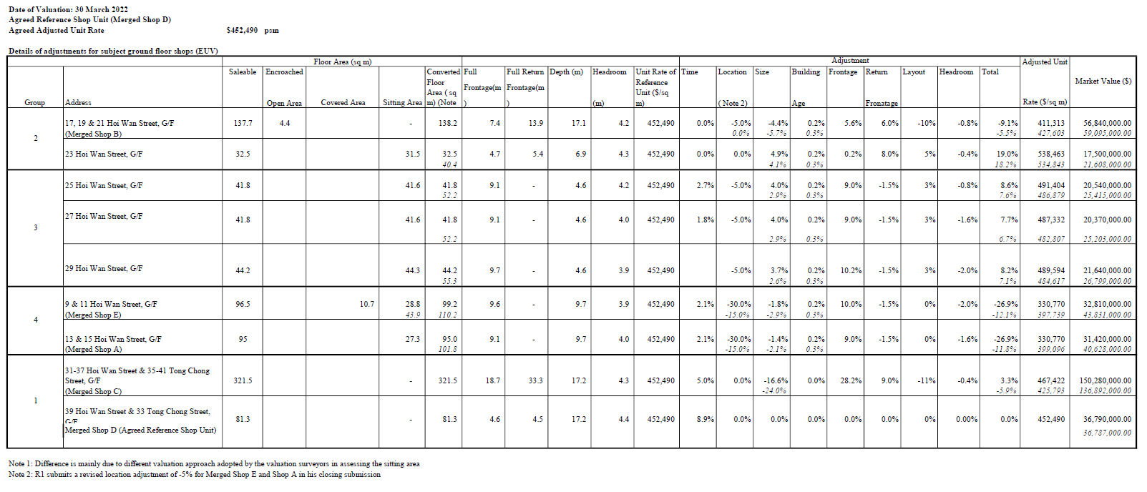

Appendix 2

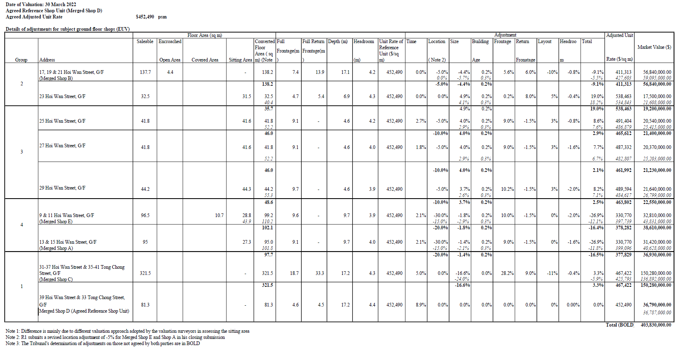

Appendix 3
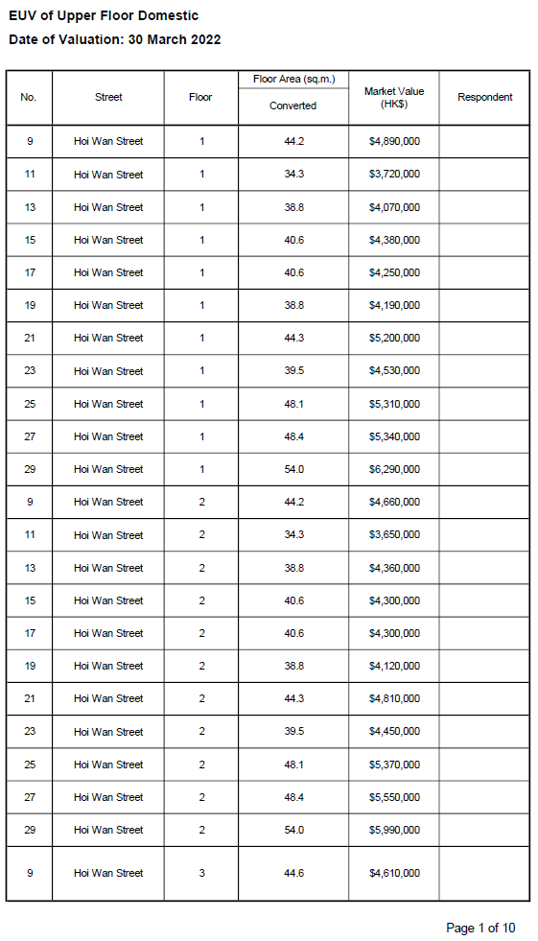
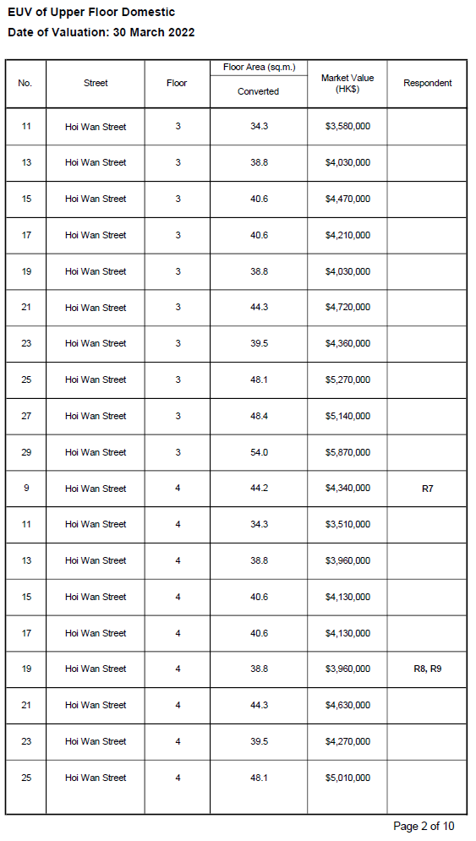

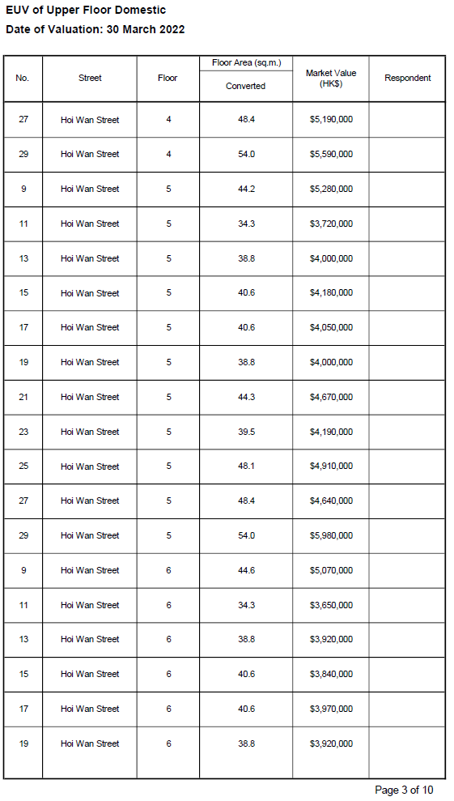

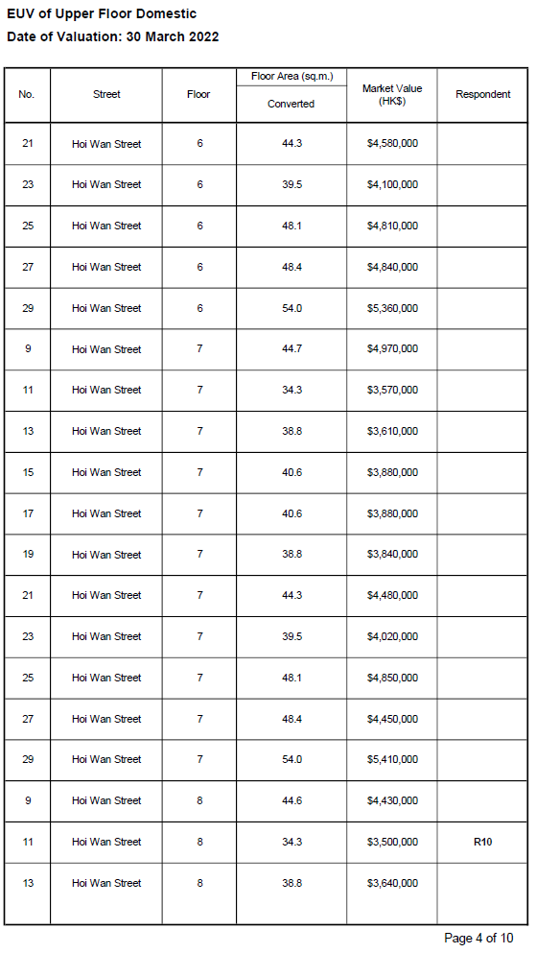

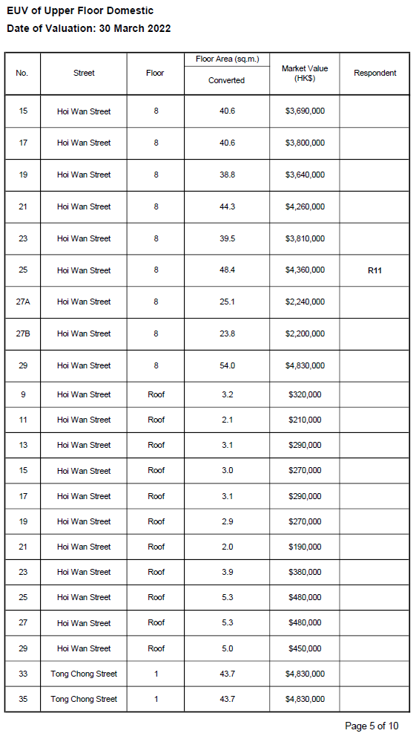

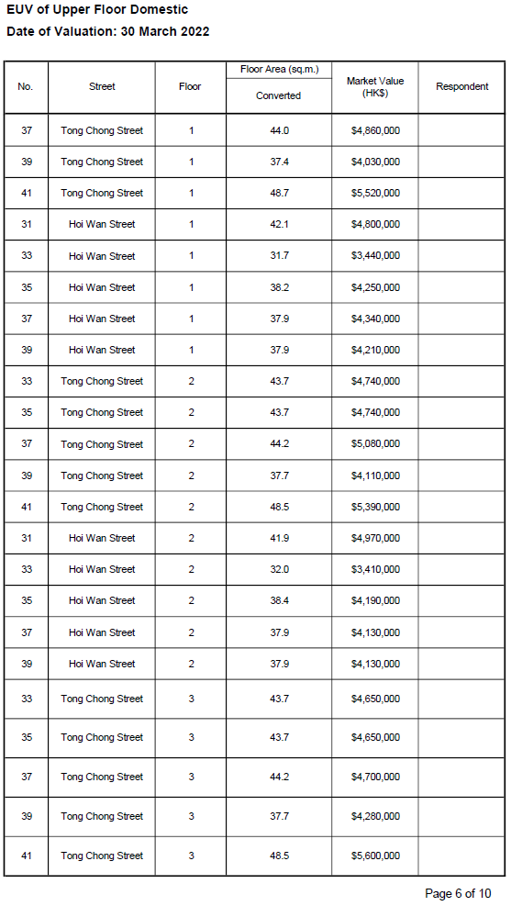

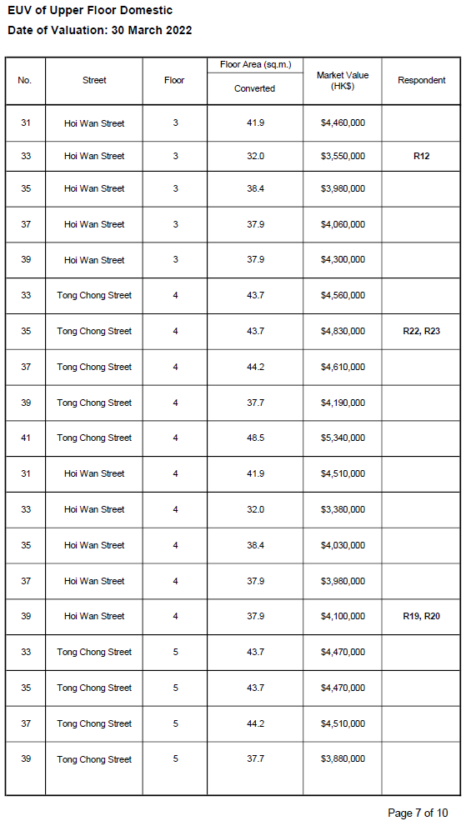

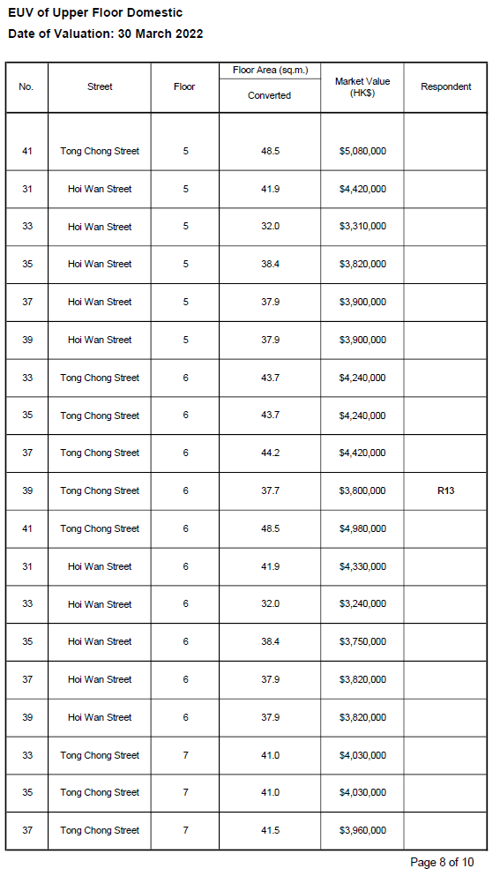

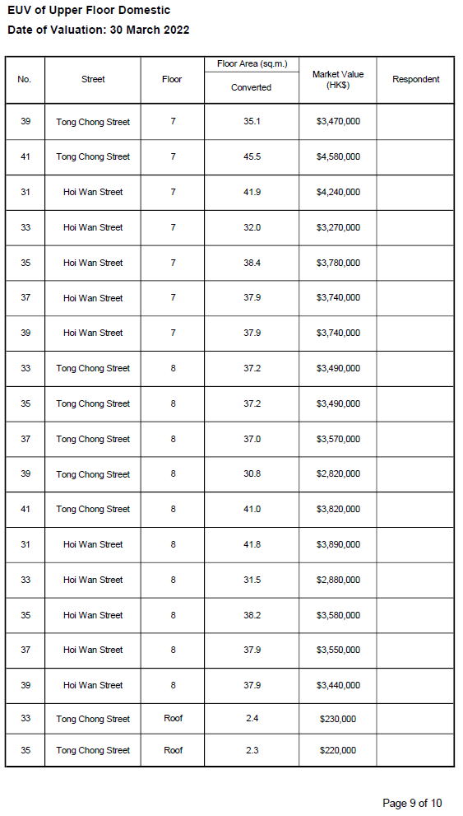

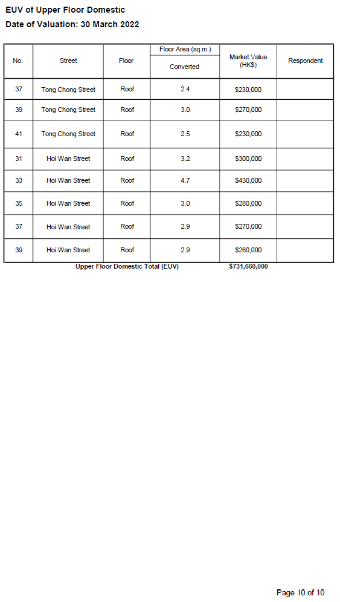

Appendix 4
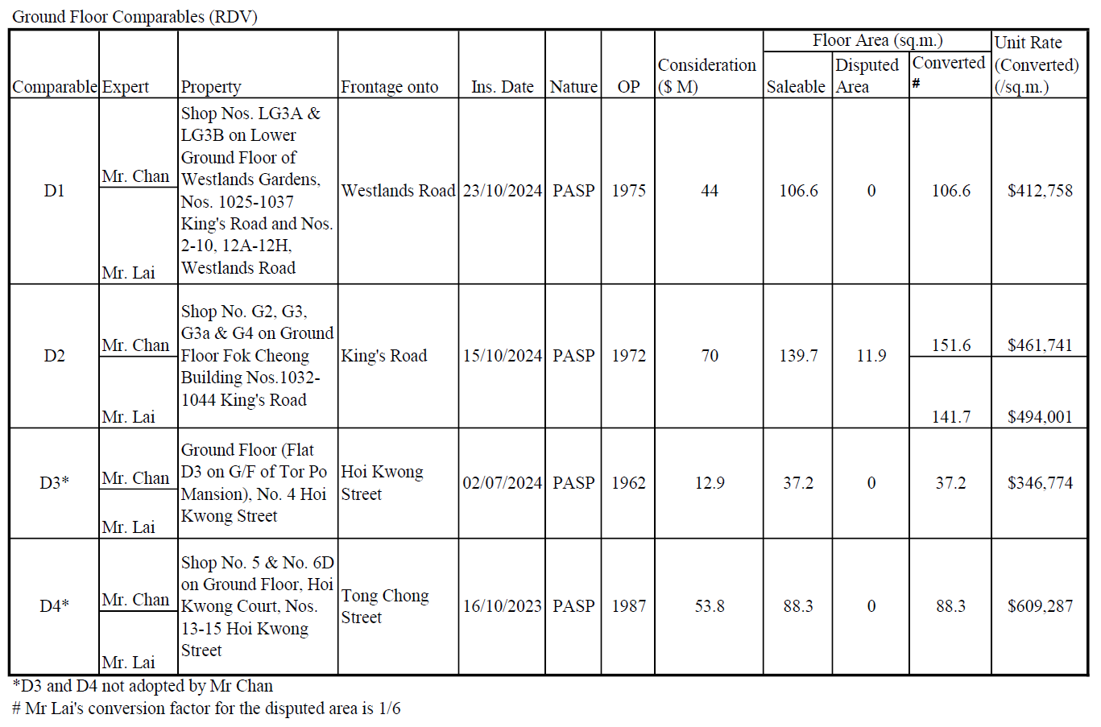
Appendix 5

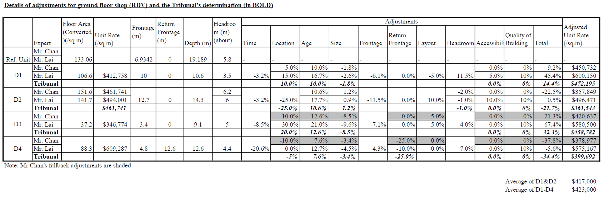
Appendix 6

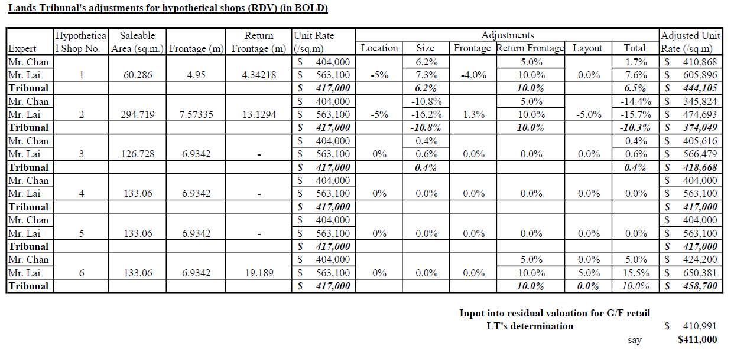

Appendix 7

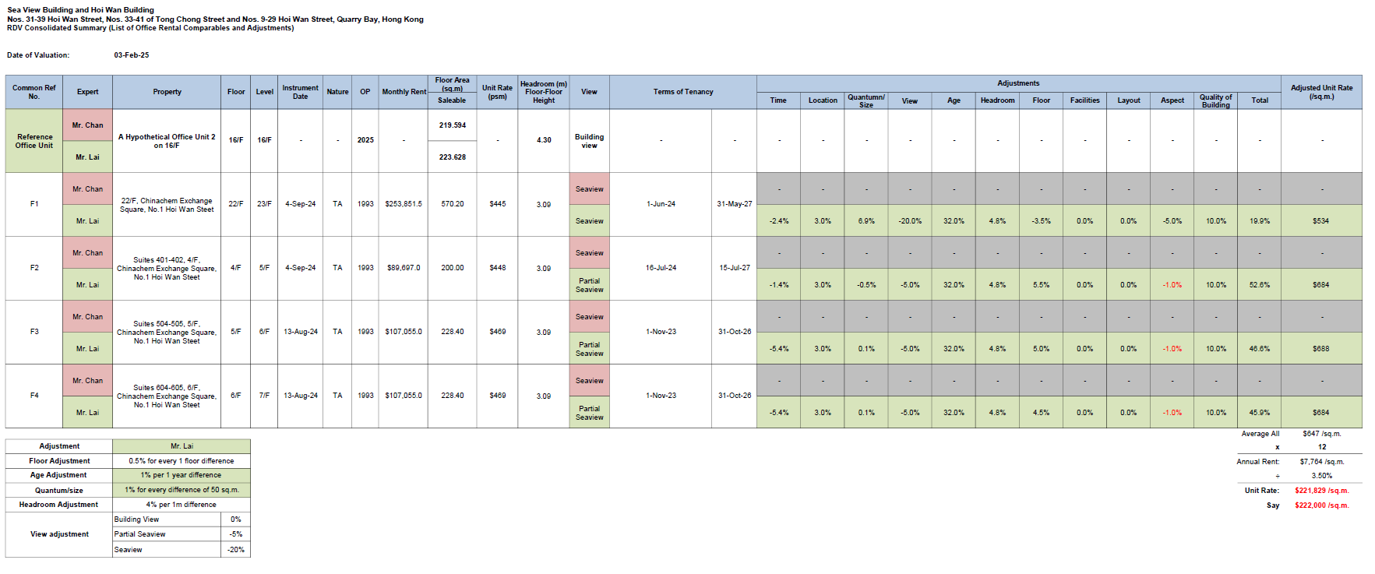

Appendix 8
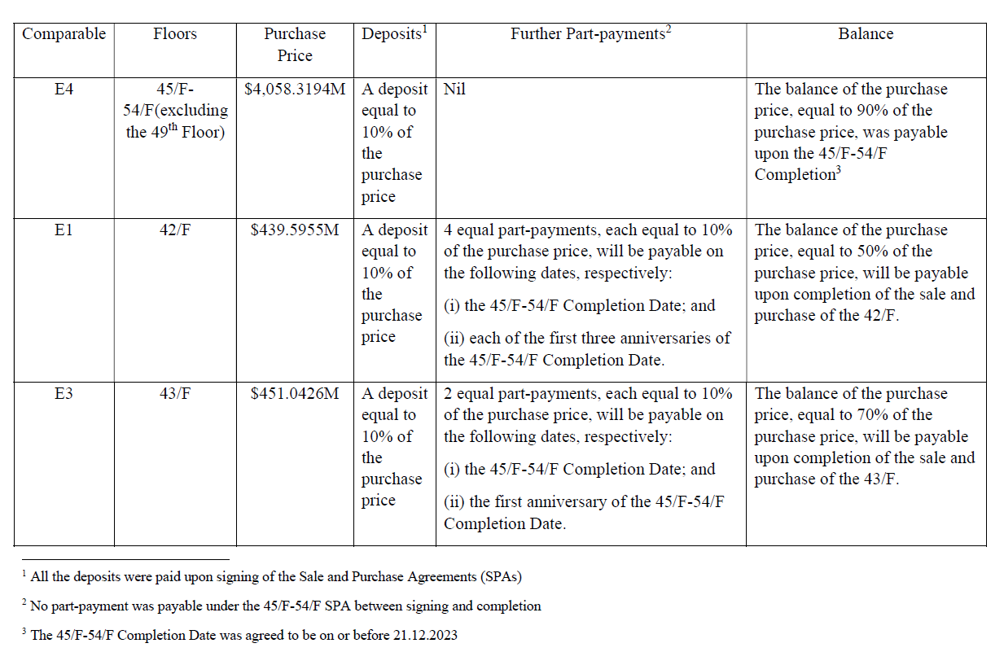
Page 1 of 2
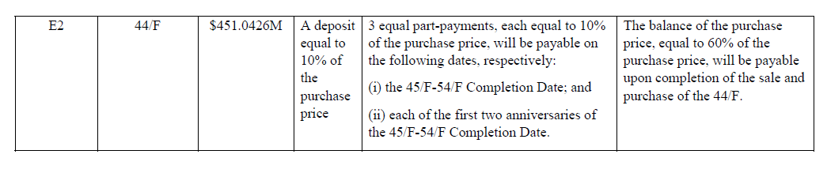

Page 2 of 2
Appendix 9

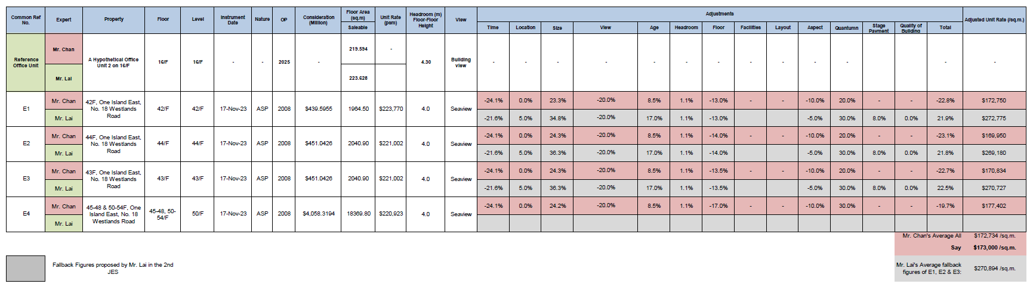

Appendix 10
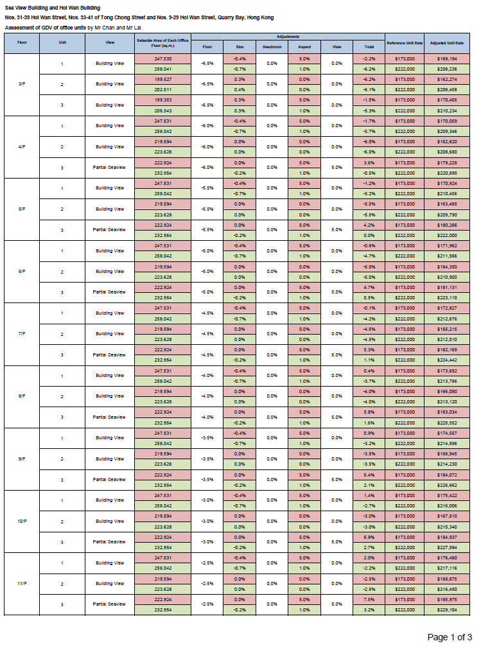

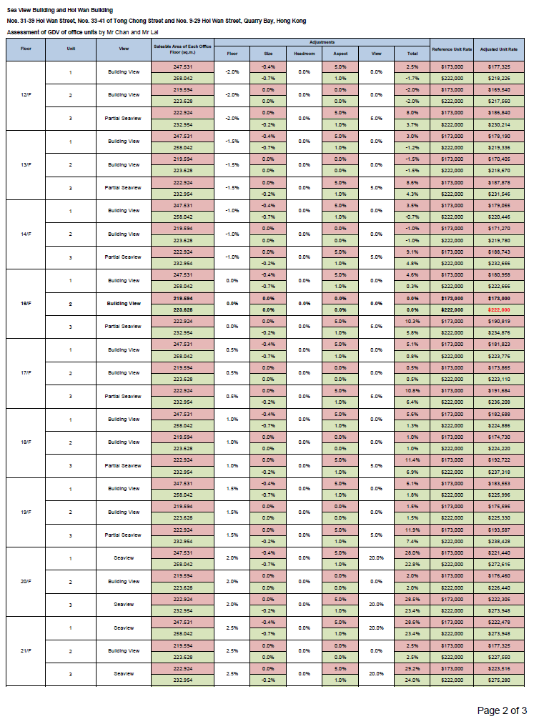

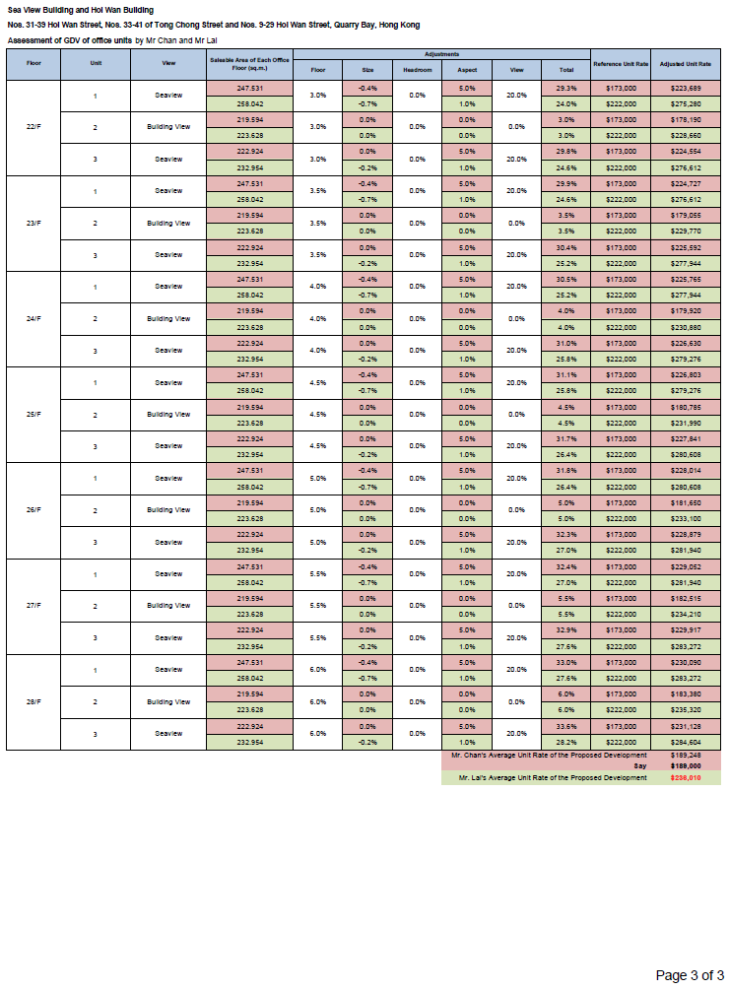

Appendix 11
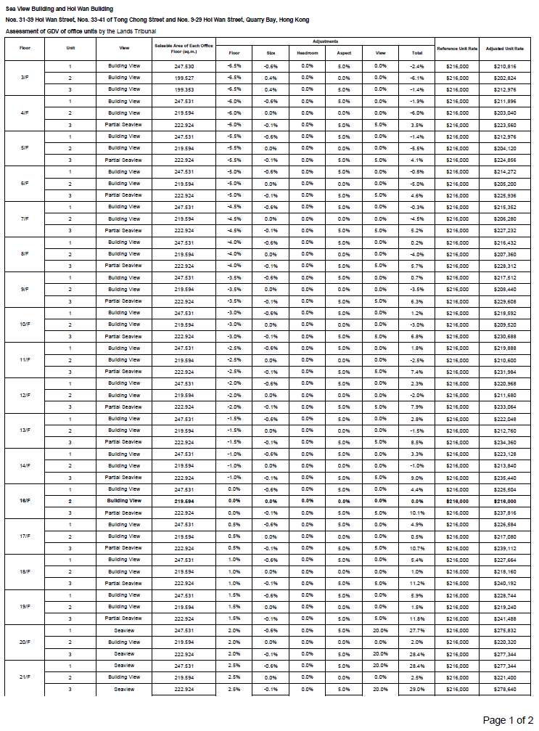
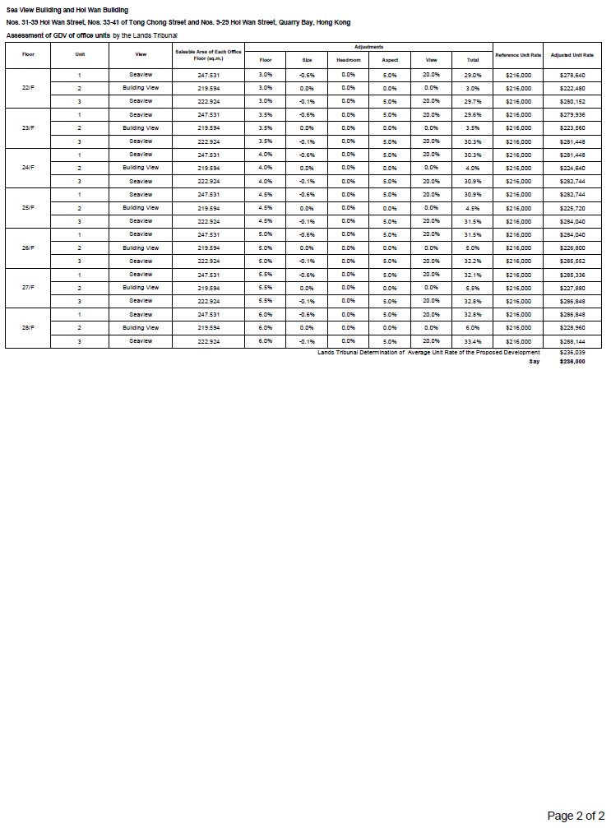

Appendix 12
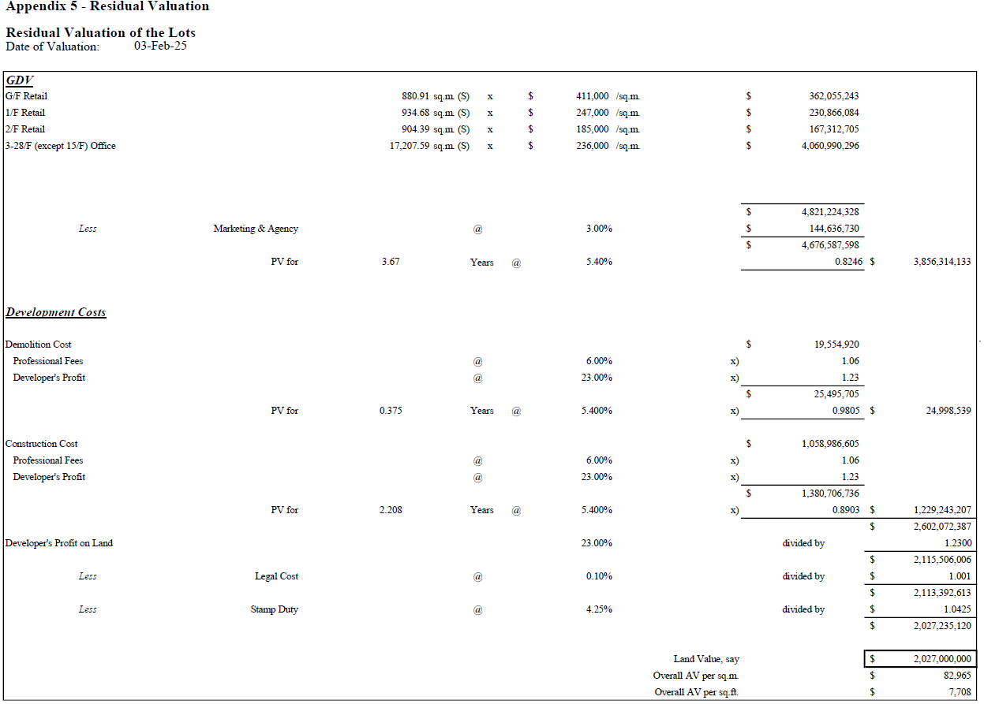

EB/0037-0070
EB/004
IB/6
B1/73
D1/86
D4/949 & D2/450, 453 & 455
D4/0916
D2/0921
§§ 247-248 of Peace Ever
This is the apportioned value of Merged Shop E (9 & 11 Hoi Wan Street, G/F), based on the agreed percentage between the parties as set out at §22 above.
EB/209-216
D6/1364
§§3.2.3-3.2.4 of HKIS Guidance Notes on Valuation of Development Land
Asia Rich Incorporation Limited and Others v Li Kam Wah and Others [2023] HKLdT 9
EB/148/§16
EB/291; As Mr Chan did not produce Investment Method of Valuation for office units, he did not provide fallback adjustments for the Chinachem comparables.
EB/86
EB/86
EB/291
EB/89
EB/87 1st paragraph
EB/90
EB/198-199
Far Union, supra, §192
EB/148
As at 30.6.2024
Mr Mok’s closing submissions §122
EB/154
EB/111
EB/154
R1 closing submissions §55
D6/1370
EB/290
EB/215
Mr Mok cites those judgments in his closing submissions at §172
Applicant’s closing submission §174
Applicant’s closing submission §175
D6/1357
D6/1357
D6/1357
Applicant’s closing submissions §180 (d)
Applicant’s closing submissions §180 (c)
D6/1300-1301
C18/4539
C18/4540-4584

